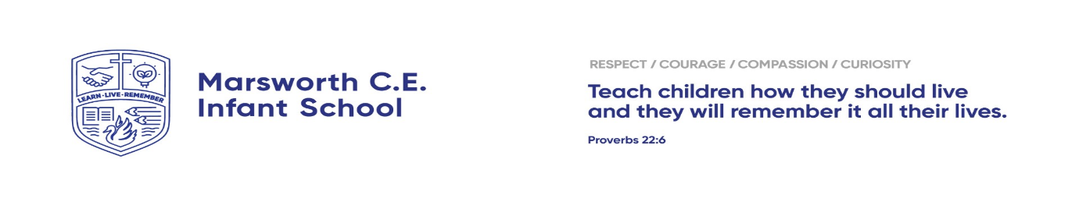
Phonics Information for KS1 Parents
September 2025
Dear Parents/ Carers,
At school this year your child will be taught Phonics through ‘Little Wandle Letters and Sounds’. We are very excited about this lovely, new scheme! Please read this letter to find out more!
Phonics is the process by which we initially teach children to read. It is very important in the early stages of learning to read and is therefore taught daily in EYFS and KS1. The ‘Little Wandle’ scheme has lots of reading and writing practice. The sessions are pacey and will engage the children and help them develop reading skills and love of reading. Your child will be assessed regularly to ensure they are progressing well.
Supporting your child with phonics at home:
You can support your children at home by listening to them saying the sounds they have learnt at school. Correct pronunciation of sounds can be found on the ‘For Parents’ section of the website. There is also support videos to learn how we teach phonics. The website address is: https://www.littlewandlelettersandsounds.org.uk/resources/for-parents/
Supporting your child with reading at home:
The information below is directly from the website.
Although your child will be taught to read at school, you can have a huge impact on their reading journey by continuing their practice at home. There are two types of reading book that your child may bring home: A reading book. This will be at the correct phonic stage for your child. They should be able to read this fluently and independently. A sharing book. Your child will not be able to read this on their own. This may be a school library book and is for you both to read and enjoy together.
Reading book:
This book has been carefully matched to your child’s current reading level. If your child is reading it with little help, please don’t worry that it’s too easy – your child needs to develop fluency, confidence in reading and a deeper understanding. Listen to them read the book. Remember to give them lots of praise – celebrate their success! If they can’t read a word, read it to them. After they have finished, talk about the book together. If unsure please refer to the instructions inside the front of the book. Please use the school reading record to date when you have heard your child read and feel free to comment on how they have got on.
Sharing book:
In order to encourage your child to become a lifelong reader, it is important that they learn to read for pleasure. The sharing book is a book they have chosen for you to enjoy together. Read it to or with them. Discuss the pictures, enjoy the story, predict what might happen next, use different voices for the characters, explore the facts in a non-fiction book. The main thing is that you have fun!
your child will bring home a book from the stage each week. These will be collected in and changed on Thursdays. Make sure your child’s books and reading record are in their book bag every day. If you have any questions, please speak to your child’s class teacher. Thank you for your support,

Kind Regards
Angela Polatci and Karen Scott
Headteacher English Coordinator



