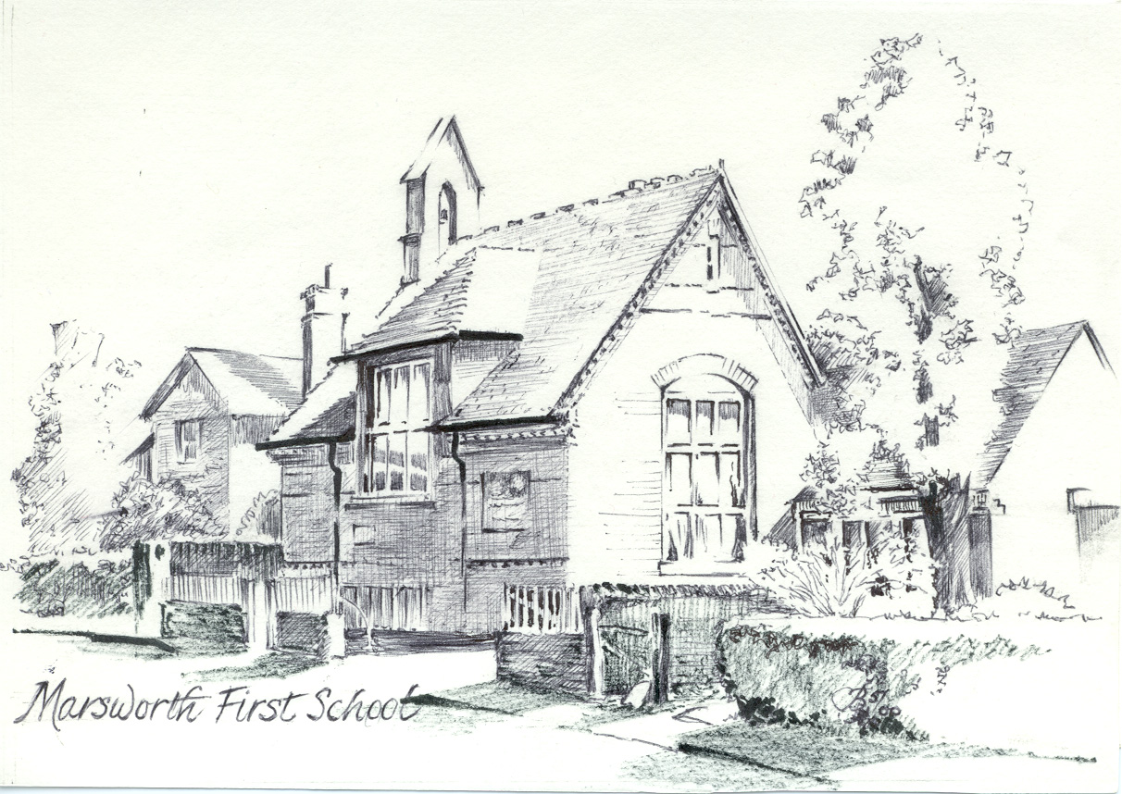
Marsworth CE Infant School

Vicarage Road, Marsworth, Bucks HP23 4LT
Tel/Fax: 01296 668440
E-mail : office@marsworth.bucks.sch.uk Website: www.marsworthschool.co.uk
Headteacher: Mrs Angela Polatci
RESPECT, COURAGE, COMPASSION, CURIOSITY
‘Teach children how they should live,
and they will remember it all their lives.’ Proverbs 22:6

PARENT CODE OF CONDUCT

We are very fortunate at Marsworth CE Infant School to have a large majority of supportive and friendly parents who:
- recognise that educating children is a partnership between parents and school staff;
- understand the importance of a good working relationship;
- understand the need to equip children with the necessary skills for independence and adulthood.

As a school we welcome and encourage parents to participate in the life of the school and to support their children in becoming inquisitive and independent learners. All teachers abide by the Professional Standards as laid down by Government and within the School’s Code of Conduct Policy and we work consistently and positively to offer the best education for the children.

The purpose of the Parent Code of Conduct is to provide a reminder about expectations of conduct so that we can all work together to ensure a safe and positive school environment for children and adults.

In addition to our Home School Agreement we expect parents and visitors to:
- understand that parents and teachers need to work together for the benefit of the children;
- demonstrate that all members of our school community should be treated with respect;
- respect and work in partnership with the professional judgements of the staff (e.g. regarding grading of work and behavioural incidents)

In order to maintain a peaceful and safe school environment, the school can not tolerate:
- any behaviour which causes upset, distress or alarm
- shouting, either in person or over the telephone
- speaking in a rude, disrespectful, aggressive or threatening tone
- physical intimidation (e.g. standing very close)
- use of offensive language, swearing or displaying temper
- sexist, racist or any other type of inappropriate comment
- insulting, abusive or threatening e-mails or other written communication
- defamatory, offensive or derogatory comments regarding the school or any of the staff, children or parents on social network sites (see appendix 1). Any concerns must be made through the appropriate channels by speaking initially to the class teacher, then possibly Head Teacher, or eventually to the Chair of Governors, so that they can be dealt with fairly, appropriately and effectively for all concerned

The school reserves the right to take any necessary actions to ensure that members of the school community are not subjected to inappropriate behaviour. Please note that it is a requirement for the school that any incidents of the above are recorded.

The school acknowledges the benefits of the use of Social Media for class parent group communication and for positive celebration of the school. However photographs of the children (including the use of mobile phones and video) must not be posted. This is for safety and security purposes, as we have a number of children whose parents have expressed a preference that they not be photographed on the media form all parents are required to submit on their child’s entry to the school.

We trust that all parents will fully support this code of conduct and thank you for your continuing support of the school.

NAME: ______________________________________

SIGNATURE: _________________________________

DATE: ______________________

PARENT CODE OF CONDUCT – APPENDIX 1: Inappropriate use of Social Media:

Nationally social media websites are being increasingly used to fuel complaints and campaigns against schools, school staff, Head Teachers and in some cases parents and children. Marsworth CE Infant School considers the use of social media in this way as unacceptable and not in the best interests of the children or the school community. Any concerns parents may have should be addressed using the appropriate channels by speaking initially to the class teacher, then possibly Head Teacher, or eventually to the Chair of Governors, so that they can be dealt with fairly, appropriately and effectively for all concerned.

In the event that any child, or parent of a child being educated at our school, is found to be posting libellous or defamatory comments on Facebook or other social media sites which are personal or would bring the school into disrepute, they will be reported to the ‘report abuse’ section of the network site. All social media networks have clear rules about the content that can be posted and provide robust mechanisms to report activity which breaches these. The school will also expect that the child or parent removes such comments immediately.

Should any member of the school community use any social media site to publically humiliate another this will be taken very seriously and will be treated as an incidence of bullying behaviour which is not tolerated in our school.

In serious cases the school will consider its legal options to deal with any mis-use of social networking sites.

