
Vicarage Road, Marsworth, Nr Tring, Herts HP23 4LT
Tel/Fax: 01296 668440
E-mail : office@marsworth.bucks.sch.uk
RESPECT, COURAGE, COMPASSION, CURIOSITY
‘Teach children how they should live,
and they will remember it all their lives.’ Proverbs 22:6

Calculation Policy
Reviewed: January 2024
Date of next review – January 2026

Through our values of Respect, Courage, Compassion and Curiosity, Marsworth CE Infant School provides a unique, nurturing environment to inspire a love of learning in our children.
‘Teach children how they should live, and they will remember it all their lives.’ Proverbs 22:6
We care for each child as an individual to support their education, social, spiritual and moral growth.
Implementation
We are passionate about the developments children make in mathematics. Children in all year groups are introduced to new concepts by exploring hands-on resources before moving to pictorial and abstract levels of questioning. We aim for a balance between mathematical fluency (arithmetic), reasoning and problem solving in order to ensure that our children are able to apply the skills that they learn in the classroom to everyday life.
Children are also given opportunities to apply their learning of mathematics in other subjects. By creating a rich and exciting mathematical curriculum, we aim to create budding mathematicians, who have deep understanding of number and a desire to tackle a range of problems in order for them to become life-long mathematicians.
Children will initially be introduced to number, counting, calculations, shape, measure and geometry through practical, oral and mental activities. Once they begin to understand these concepts they will be encouraged to informally record before finally using mathematical signs and symbols to record in a more organised/ formal way.
This policy explains the methods used to help our pupils with calculations. The methods we are advocating are in line with the new National Curriculum (September 2014). All staff in school work from this document so that we can ensure the consistency of our approach and can make sure that the children move onto the next step when they are ready whilst ensuring appropriate progression through from EYFS to the end of KS1.
Whichever of the four operations of addition, subtraction, multiplication and division is being taught children need to experience all of the following steps to completely understand it:
1) Practical use of objects.
2) Use of pictures or numicon.
3) Use of numberlines, number beads, number fans and/or number squares.
4) Use of a compact/formal written method.

How to start working out a calculation with children:
Children should be taught and encouraged to use the following processes in deciding what approach they will take to a calculation so that they ensure they select the most appropriate method for the numbers involved:
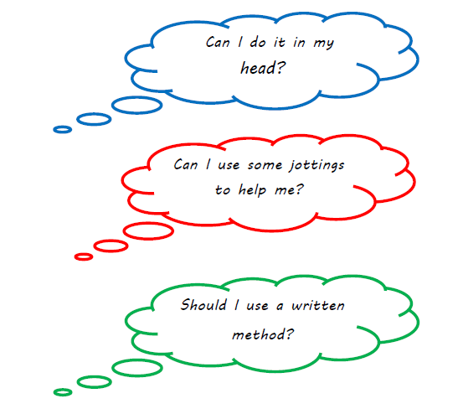
We follow the Essential Maths Scheme of work for Maths at Marsworth School, with additional resources to supplement. For example, Number blocks in EYFS. Nrich or NCETM for problem solving in KS1
Examples of working out can be found in Appendix 1
Progression in teaching Addition, Subtraction, Multiplication and Division
Mental Skills - Addition  • Recognise the size and position of numbers  • Count on in ones and tens  • Know number bonds to and within 10,20 and then 100  • Add multiples of 10 to any number  • Partition and recombine numbers  • Bridge through 10  Understand that addition can be done in any order and use known facts to derive associated subtraction facts (commutative) | Key Vocabulary Addition  • add  • addition  • plus  • and  • count on  • more  • sum  • total  • altogether
Mental Skills - Subtraction  • Recognise the size and position of numbers  • Count back in ones and tens  • Know number facts for all numbers to and within 20 then 100  • Subtract multiples of 10 from any number  • Partition and recombine numbers (only partition the number to be subtracted)  • Bridge through 10 | Key Vocabulary - Subtraction  • subtract  • less  • take away  • fewer  • minus  • difference  • count back  • between
Mental Skills - Multiplication  • Recognise the size and position of numbers  • Count on in different steps 2s, 5s, 10s  • Double numbers up to 10 then 20  • Recognise multiplication as repeated addition  • Quick recall of multiplication facts  • Use known facts to derive associated division facts (understand commutativity)  • Use known facts to generate other facts | Key Vocabulary – Multiplication  • lots of  • groups of  • times  • multiply  • multiplication  • multiple  • array  • double  • repeated addition
Mental Skills - Division  • Recognise the size and position of numbers  • Count back in different steps 2s, 5s, 10s  • Halve numbers to 20 and then to  • Recognise division as repeated subtraction  • Quick recall of division facts  • Use known facts to derive associated facts  • Divide by multiples of 10 | Key vocabulary - Division  • lots of  • groups of  • share  • group  • halve  • divide  • division  • divided by remainder

EYFS
30-50 months  Uses some number names and number language  spontaneously.  • Uses some number names accurately in play.  • Recites numbers in order to 10.  • Knows that numbers identify how many objects are in a set.  • Beginning to represent numbers using fingers, marks on paper  or pictures.  • Sometimes matches numeral and quantity correctly.  • Shows curiosity about numbers by offering comments or  asking questions.  • Compares two groups of objects, saying when they have the  same number.  • Shows an interest in number problems.  • Separates a group of three or four objects in different ways,  beginning to recognise that the total is still the same.  • Shows an interest in numerals in the environment.  • Shows an interest in representing numbers.  • Realises not only objects, but anything can be counted,  including steps, claps or jumps. | 40-60 months  Recognise some numerals of personal significance.  • Recognises numerals 1 to 5.  • Counts up to three or four objects by saying one number  name for each item.  • Counts actions or objects which cannot be moved.  • Counts objects to 10, and beginning to count beyond 10.  • Counts out up to six objects from a larger group.  Selects the correct numeral to represent 1 to 5, then 1 to 10  objects.  • Counts an irregular arrangement of up to ten objects.  • Estimates how many objects they can see and checks by  counting them.  • Uses the language of ‘more’ and ‘fewer’ to compare two sets  of objects.  • Finds the total number of items in two groups by counting all  of them.  • Says the number that is one more than a given number.  • Finds one more or one less from a group of up to five objects,  then ten objects.  • In practical activities and discussion, beginning to use the  vocabulary involved in adding and subtracting.  • Records, using marks that they can interpret and explain.  • Begins to identify own mathematical problems based on own  interests and fascinations.
Before addition can be introduced, children in Reception build on concepts taught in Nursery by working through the number objectives in the 40 – 60 month band of Development Matters. Children need to have a secure knowledge of number in order to begin addition.  Children are then introduced to the concept of addition through practical games and activities. Children act out addition calculations to physically add two groups of objects together. This is reinforced by opportunities provided in the outdoor area for the children to use addition e.g. adding together groups of building blocks, twigs etc.  Children build on their previous knowledge of ‘more’ by learning that adding two groups of objects together gives them a larger number (more objects).  Adults model addition vocabulary supported by age appropriate definition. | Before subtraction can be introduced, children in Reception build on concepts taught in Nursery by working through the number objectives in the 40 – 60 month band of Development Matters. Children need to have a secure knowledge of number in order to begin subtraction.  Children are then introduced to the concept of subtraction through practical games and activities. Children act out subtractions to physically subtract a number of objects from a group. This is reinforced by opportunities provided in the outdoor area for the children to count e.g. counting building blocks, twigs etc. Children build on their previous knowledge of ‘less’ by learning that subtracting means taking away a certain number of objects from a group (leaving them with less objects).  Adults model subtraction vocabulary supported by age appropriate definition.

EYFS
Addition/  Subtraction | Say which number is one more or one less than a given number.  Using quantities and objects, they add and subtract two  single- digit numbers and count on or back to find the answer.
Addition |  | Subtraction
Sing nursery rhymes and simple songs.  Use objects to show one more than a number.  Compare amounts, which has more.  Say the number one more than when playing a board game.  Experience addition as counting on, e.g. rolling a dice and moving along a number track when playing snakes and ladder  Begin to relate addition to combining two groups of objects and counting on.  Adult to model number sentences in context  Begin to record numbers and number sentences |  | Sing nursery rhymes, involving something being taken away in each verse e.g. 5 little men in a flying saucer.  Begin to relate subtraction to taking objects away from a group and counting what is left.  Compare amounts which has less.  Find different ways of recording for subtraction e.g. objects, fingers or crossing out  Children record number sentences related to practical work.  Use fingers/objects to count back  Begin to record numbers and number sentences
Vocabulary
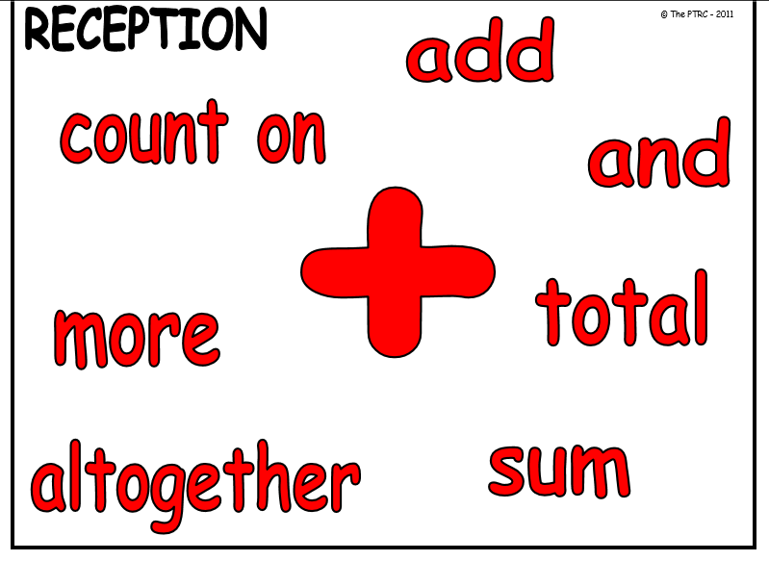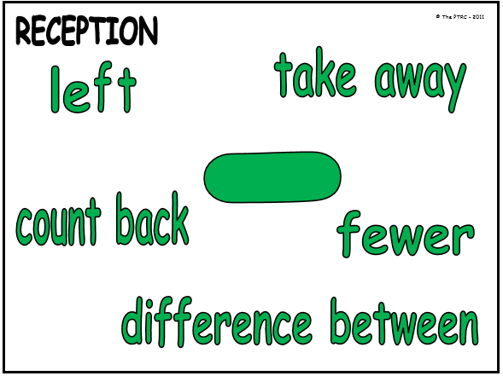

Addition  EYFS | Subtraction  EYFS
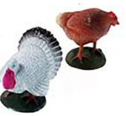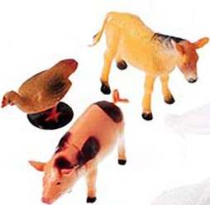  Which farm has more?  How many animals altogether?  How can we write the calculation?  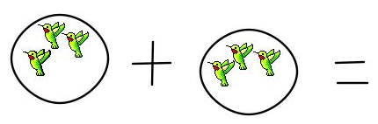  3 + 3 = 6  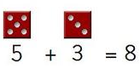  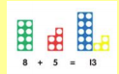  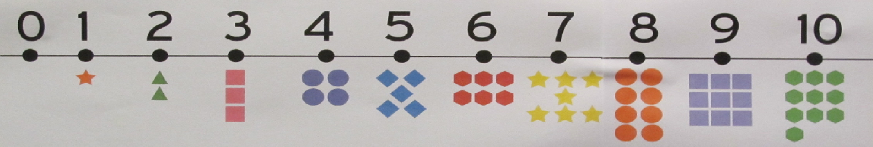 | 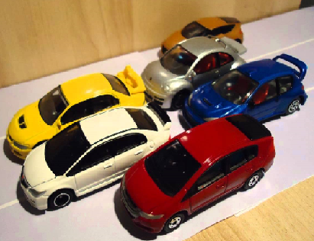  I have 6 cars, give 2 to your friend, how many do you have now?  What does the calculation look like?  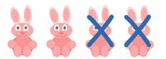4 – 2 =  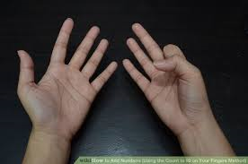10 – 2 = 8  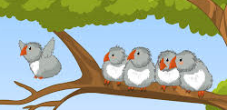  Number stories: There were 5 birds, 1 flew away, how many are left?

Year 1
Addition/  Subtraction | - Read, write and interpret mathematical statements involving addition (+), subtraction (–) and equals (=) signs  - represent and use number bonds and related subtraction facts within 20  - add and subtract one-digit and two-digit numbers to 20, including zero  - solve one-step problems that involve addition and subtraction, using concrete objects and pictorial representations, and missing number problems such as  7 = – 9.
Addition |  | Subtraction
1.Use the + and = sign regularly to fully understand their meaning.  Record number sentences in a variety of ways to help the understanding of the symbols. e.g 8+4= OR 4+8= OR 12=8+4  2. Use objects to help with number pairs to 10, moving on to missing numbers. e.g 8+__=  3. Add numbers to at least 20.  4.Record simple addition number problems using the + and = sign.  e.g I had 3 sweets and my friend had 4 sweets, how many do we have altogether?  Children could:  Use objects to work it out  Draw the problem  use numicon  count on a number line  use a bead string |  | 1.Use the - and = sign regularly to fully understand their meaning.  2. To use known facts to help with number pairs. If I know 8+2=10, I also know 10-2=8 moving on to missing numbers. e.g 8-__=5  3. Subtract numbers to at least 20.  4.Record simple subtraction in a number sentence using the – and = signs e.g. There were 8 cakes on a plate. Mary ate 3 of them. How many were left?  Children could:  use objects to work this out  draw the problem  count on (find the difference)  count back on a numberline  use a beadstring
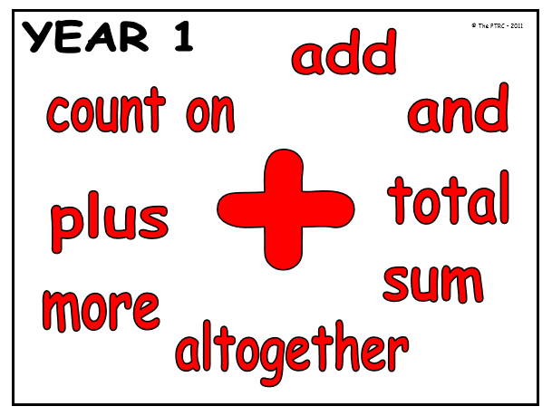 |  | 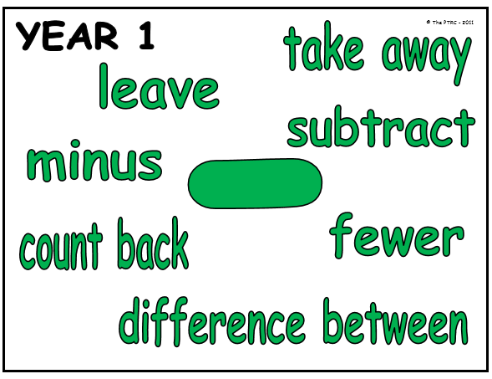

Apendix 1
Yr 1 Addition
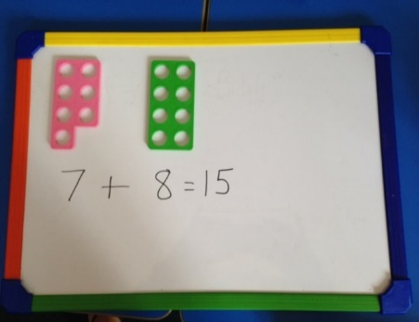
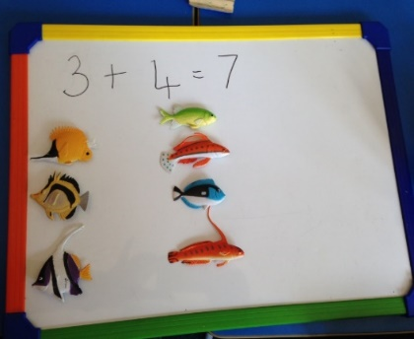
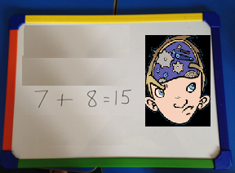
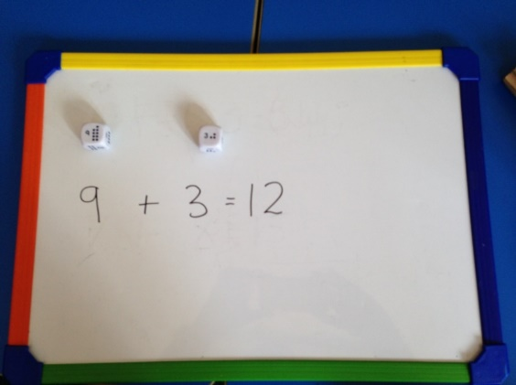
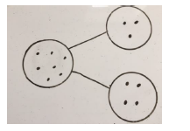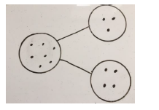
Children are encouraged to use objects to support the calculation (Concrete)
They are then supported to use pictorial representations for example, part, part whole. (Pictorial)
Then to put the biggest number in their head and count on. (Abstract)

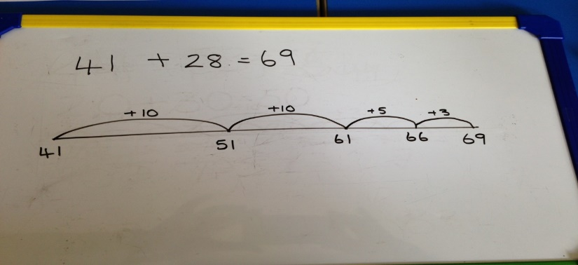
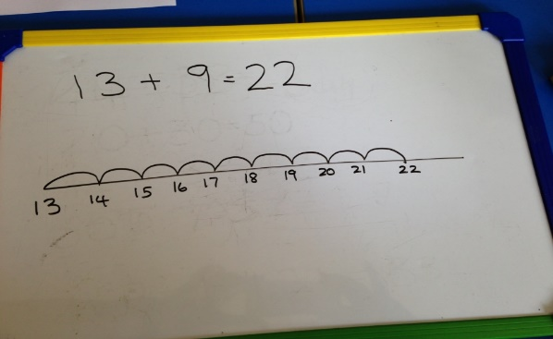
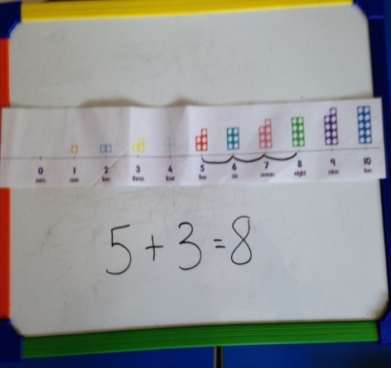
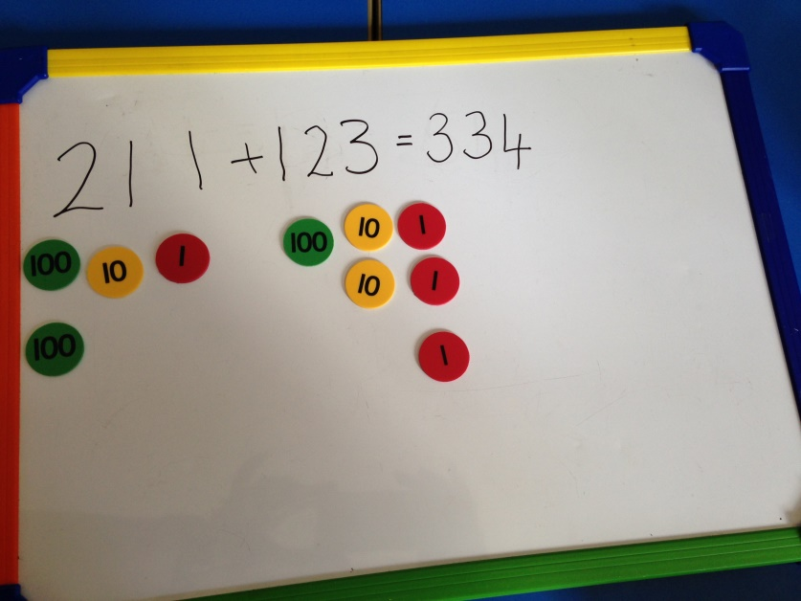

Numberlines are used to help children visualise the numbers increasing. It is important for children to use objects before moving on to number lines.
We then move on to a blank number line. Children draw the increased jumps according to their level. (They may start jumping in 1’s and move on to tens and ones.

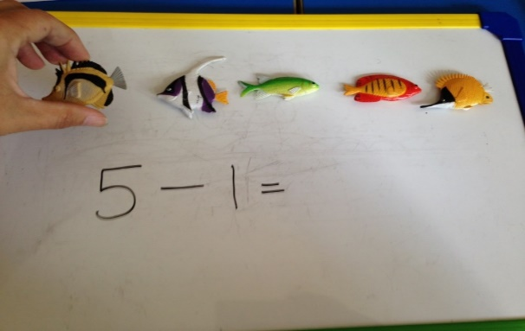
Yr 1 Subtraction
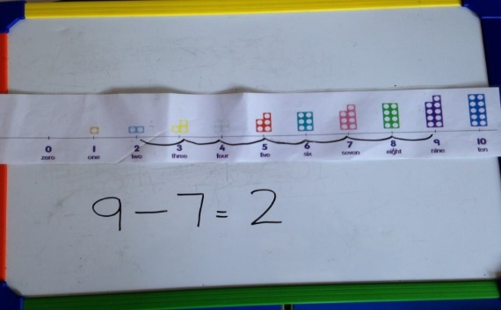
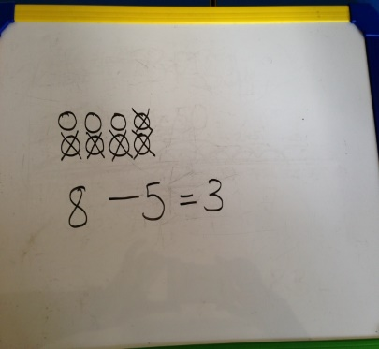

Moving on to using a number line. We can see the number decreasing. We will only move on to this when children are secure using objects.
Children can draw the number of objects and score out the number to be taken away.
We begin using objects to physically represent the numbers. The children are encouraged to take the objects away.

Year 2
Addition/  Subtraction | - solve problems with addition and subtraction: using concrete objects and pictorial  - representations, including those involving numbers, quantities and measures applying their increasing knowledge of mental and written methods  - recall and use addition and subtraction facts to 20 fluently, and derive and use related facts up to 100  - add and subtract numbers using concrete objects, pictorial representations, and mentally, including: a two-digit number and ones, a two-digit number and tens, two two-digit numbers, adding three one-digit numbers  - show that addition of two numbers can be done in any order (commutative) and subtraction of one number from another cannot  - recognise and use the inverse relationship between addition and subtraction and use this to check calculations and solve missing number problems.
Addition |  | Subtraction
- Use the = and + sign regularly and confidently.  - use objects and written methods to help solve problems.  - To know addition facts to 20 and use these to help with facts to 100. e.g If you know 8+2=10, 80+20=100.  - Use equipment and/or written methods to work out calculations.  - Ensure children are presented with calculations in lots of ways to fully secure them with what each symbol means. Understand that + can be done in any order.  - To know that + is the inverse of -. So if 182=20, 20-2=18 |  | - Use the = and – signs regulalry and confidently  - Use objects and written methods to help solve problems.  - To know subtraction facts to 20 and use these to help with facts to 100. If 10-2=8, 100-20=80  - Use equipment and/or written methods to work out calculations.  - Ensure children are presented with calculations in lots of ways to fully secure them with what each symbol means. Understand that subtraction cannot be done in any order.  - To know that + is the inverse of -. So if 20-2=18 18+2=20
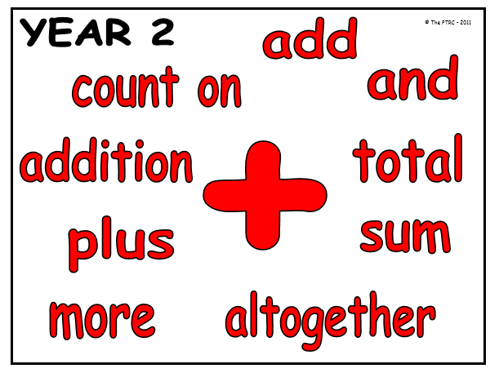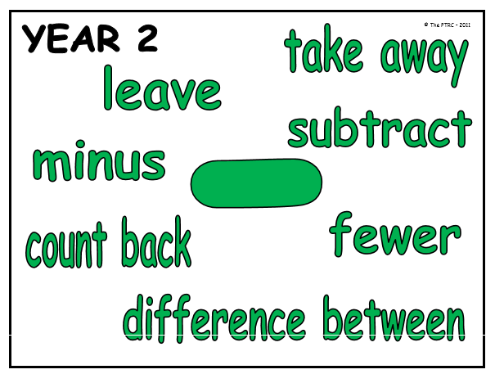

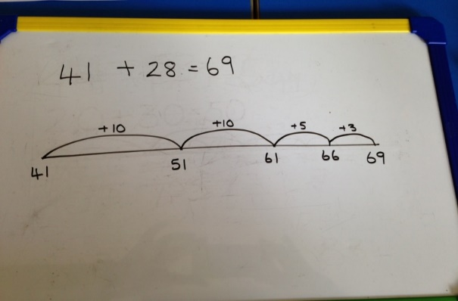
Yr 2 Addition
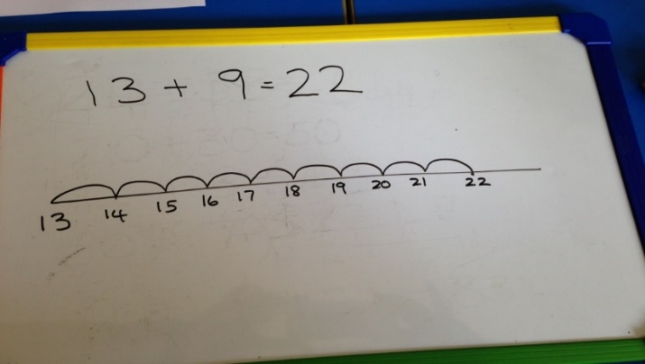

Number lines are used to help children visualise the numbers increasing. It is important for children to use objects before moving on to number lines.
We then move on to a blank number line. Children draw the increased jumps according to their level. (They may start jumping in 1’s and move on to tens and ones.

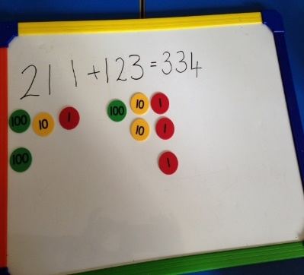
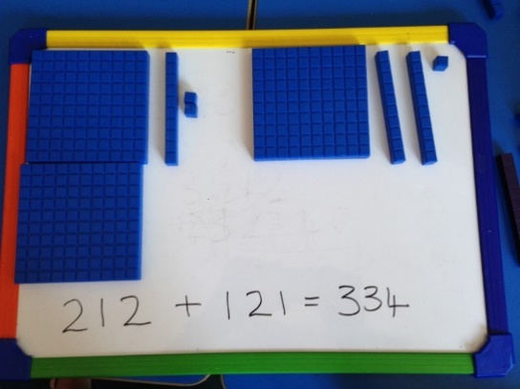
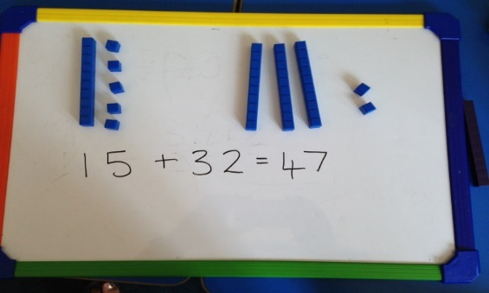

Base 10 equipment and place value discs support children when the number gets bigger.
Children are encouraged to count the 100’s or 10’s first then move on to the 1’s.

Yr 2 Addition
Partitioning numbers is always done before vertical addition. It is called partitioning because the children partition the number into 10’s and 1’s to help them add. It is important they fully recognise the place value of each digit before moving on to vertical addition.
Partitioning
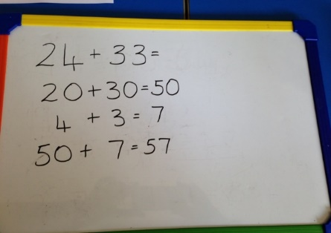
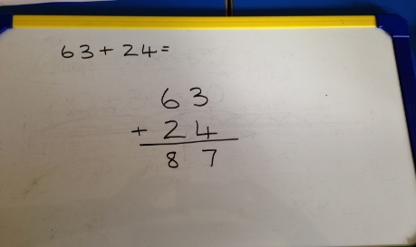

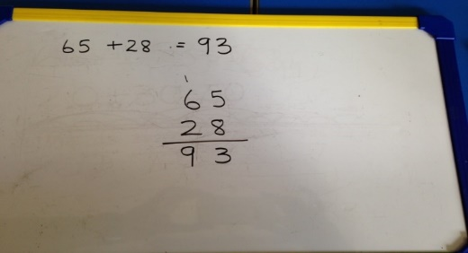
Vertical addition
Vertical addition is where we add the numbers together looking at the 10’s and 1’s. (similar to partitioning)
When the units digits bridge over 10 we put that 10 in the 10’s column. We use base 10 and place value counters to show this visually first.

Yr 2 Subtraction
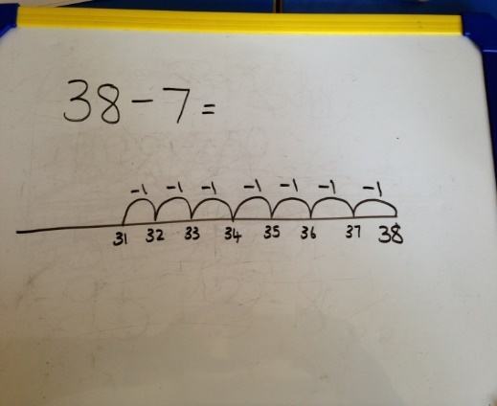
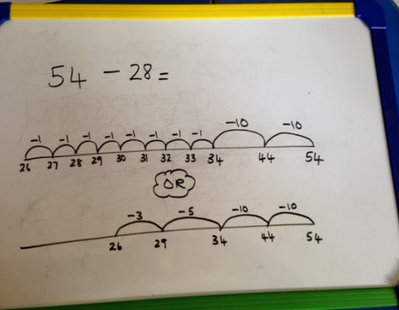
Children move on to subtracting in groups, taking away 10’s and 1’s, again moving to the left to show the number is decreasing.

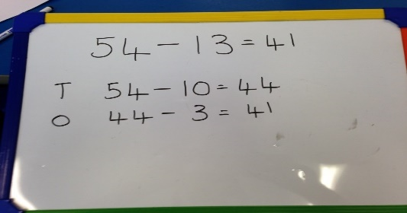
When using a blank number line children will draw it going to the left (to show the number is decreasing as they are taking away).
Partitioning
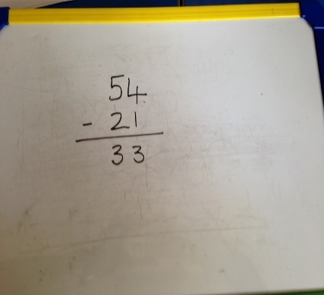
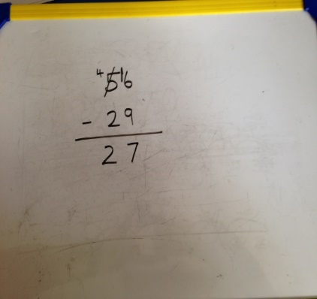
Vertical subtraction
We place the biggest number on the top and take the other number away
When we cannot subtract from the number we borrow from the next column. To begin with this is done using objects to physically represent the numbers.

EYFS
Multiplication/  Division | They solve problems, including doubling, halving and sharing.
Multiplication |  | Division
By the end of Reception, children are expected to understand the concept of doubling and to be able to double a number up to 10. Before doubling can be introduced, children need to have a secure knowledge of counting, number facts and addition in order to double.  Children are then introduced to the concept of doubling through practical games and activities, including the use of the outdoor areas. Children act out ‘doubling’ by physically add two equal groups together to find out the ‘doubles’ answer. |  | By the end of Reception, children are expected to understand the concept of halving and sharing. Before this can be introduced, children need to have a secure knowledge of counting backwards, number facts and subtraction in order to halve and share.  Children are then introduced to the concept of halving and sharing through practical games and activities. They act out ‘halving and sharing’ through activities such as sharing food for their Teddy Bear’s Picnic, sharing resources equally to play a game.
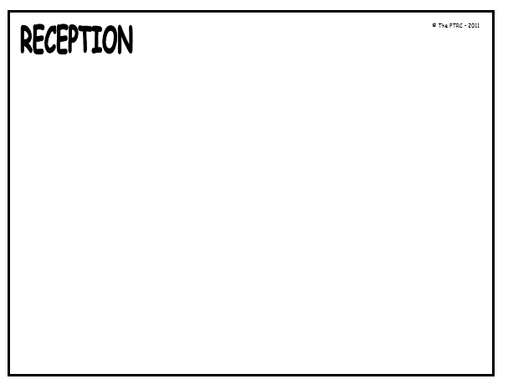
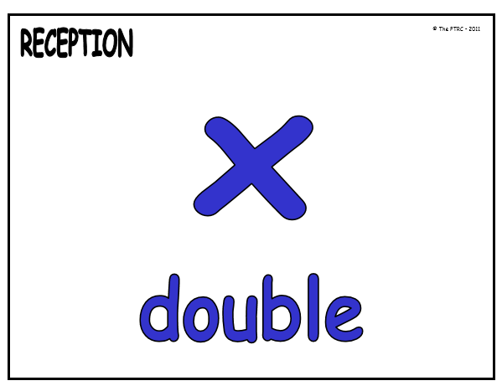
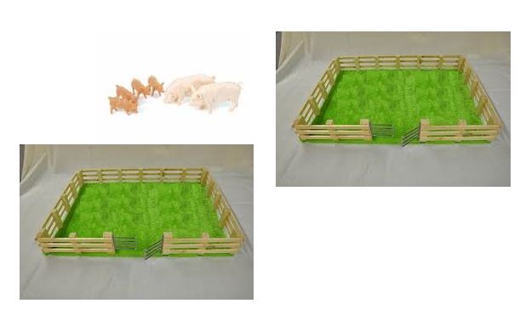
Can you share these 6 pigs into the 2 fields?
How many pigs are in each field?

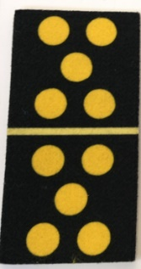
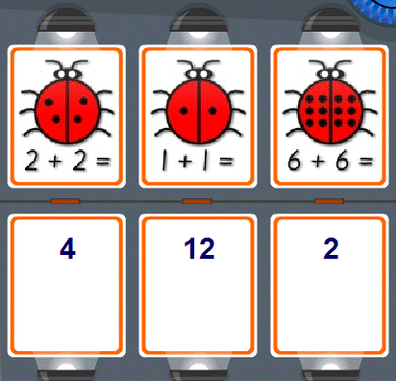
How many dots are on the domino?

Count the ladybird dots
Now put some dots on your ladybird.

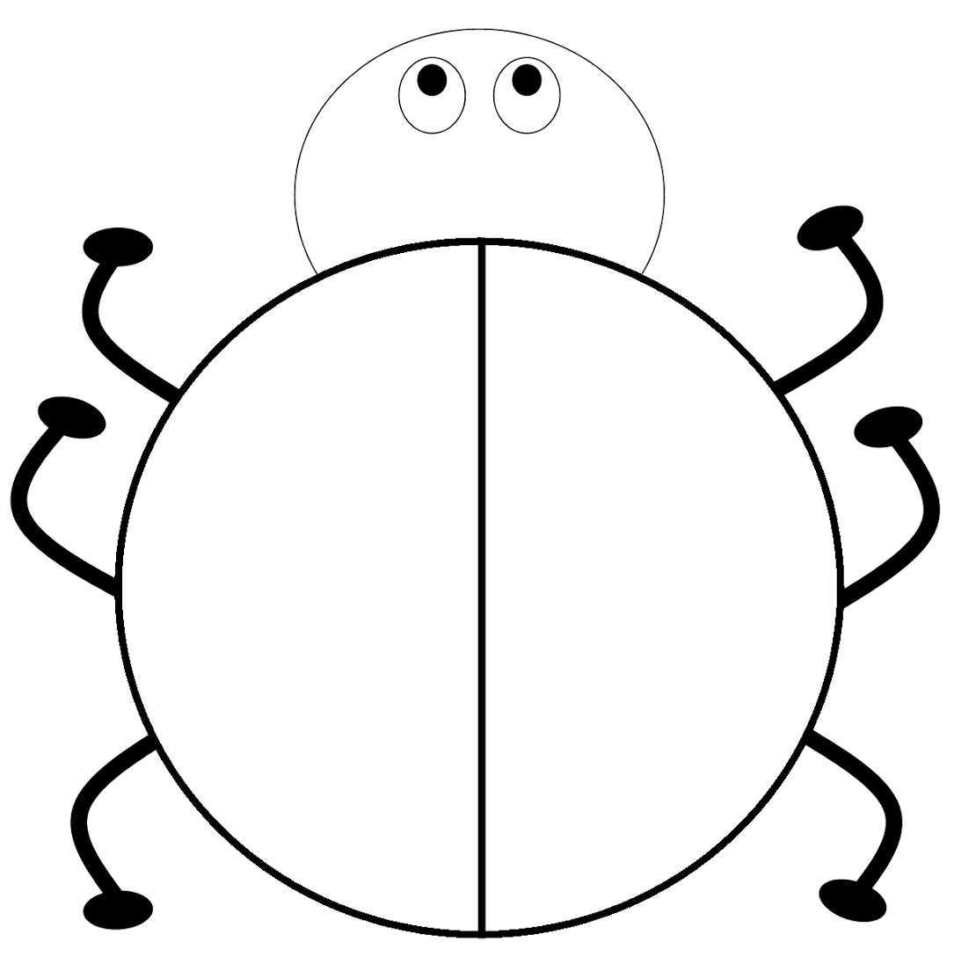

Year 1
Multiplication/  Division | Solve one-step problems involving multiplication and division, by calculating the answer using concrete objects, pictorial representations and arrays with the support of the teacher.
Multiplication |  | Division
As with Nursery and Reception, children will experience equal groups of objects and will count in 2s, 10s and 5s.  They will work on practical problem solving activities using practical resources, involving equal sets or groups.  Following this, children will develop their understanding of multiplication and use jottings to support calculation: |  | Children will continue to understand equal groups and share practical items out in play and problem solving.  They will count in 2s, 10s and 5s.  Following this, children will develop their understanding of division and use jottings to support calculation.
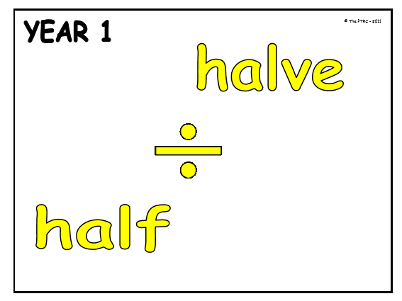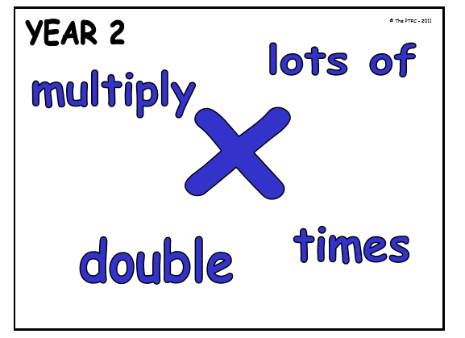

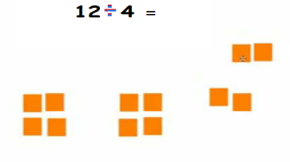
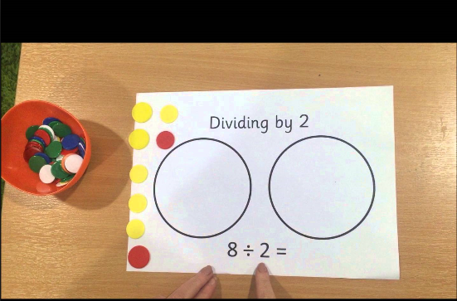
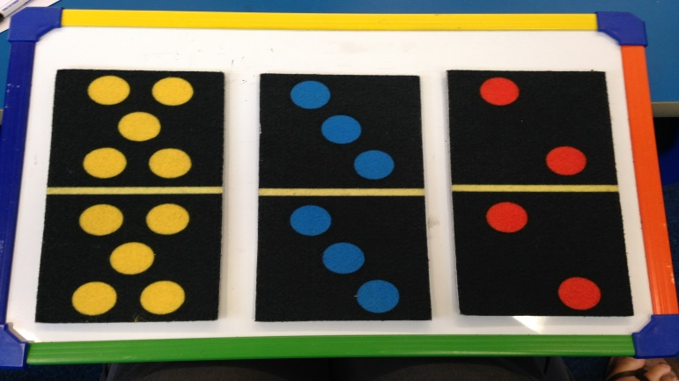
Doubling/Multiplication Division
Yr 2
Multiplication/  Division | 1.recall and use multiplication and division facts for the 2, 5 and 10 multiplication tables, including recognising odd and even numbers  2.calculate mathematical statements for multiplication and division within the multiplication  tables and write them using the multiplication (×), division (÷) and equals (=) signs  3.show that multiplication of two numbers can be done in any order (commutative) and division of one number by another cannot  4.solve problems involving multiplication and division, using materials, arrays, repeated addition, mental methods, and multiplication and division facts, including problems in contexts.
Multiplication |  | Division
1.During mental and oral counting daily in 2,3,5,10’s. Recognising which number is odd or even (songs can help with this – Number cruncher)  2.Use the X and = sign confidently understanding what it means. Listen to a problem; e.g I have 4 pairs of socks; how many socks do I have?  3.Understand that multiplication can be done in order, use equipment to demonstrate this.  4.Solve problems using equipment, drawings and mental maths to support in this area. (including arrays) |  | 1.During mental and oral counting daily in 2,3,5,10’s. How many 5’s in 20? Recognising which number is odd or even (songs can help with this – Number cruncher)  2.Use the ÷ and = sign confidently understanding what it means. Listen to a problem; e.g I have 12 cakes, I want to share them with 6 friends, how many cakes do they get each?  3.Understand that division cannot be done in order, use equipment to demonstrate this.  4.Solve problems using equipment, drawings and mental maths to support in this area. (including arrays.
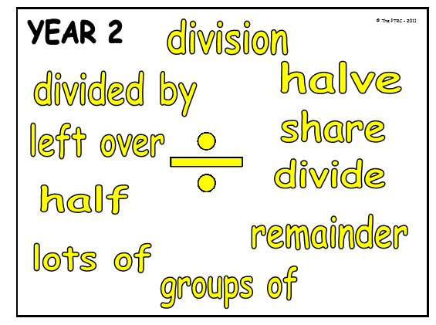

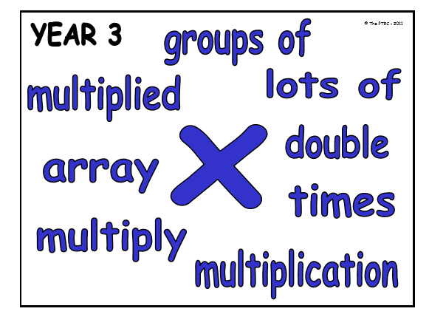

Yr2 Multiplication
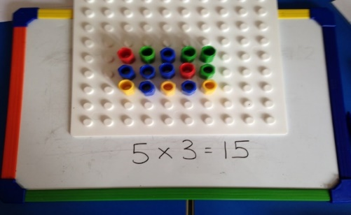
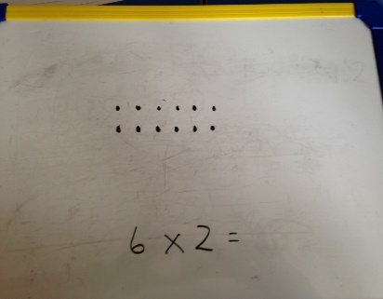
Arrays help children to visualise the multiplication.
They can be made using objects, egg boxes, baking trays or drawing.

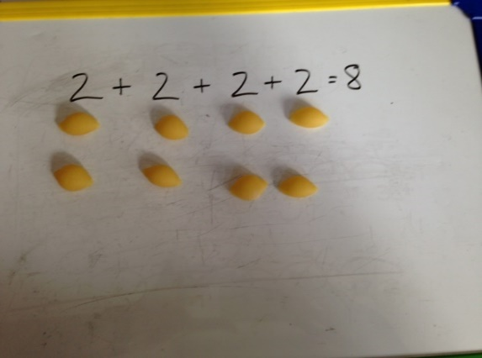
Multiplication is introduced as repeated subtraction.
So the above calculation would be
2x4= or 4x2=

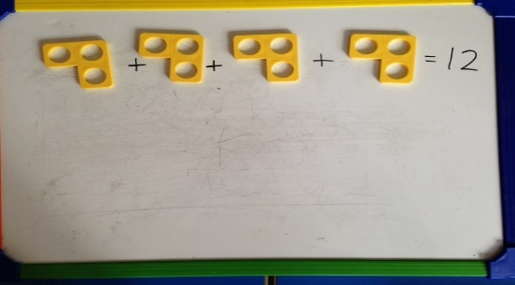
Repeated addition using numicon shapes.

Yr 2 Division
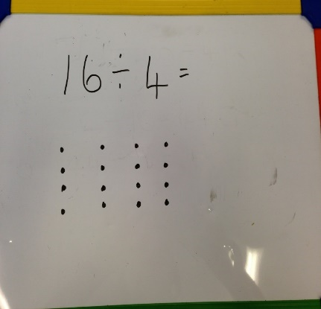
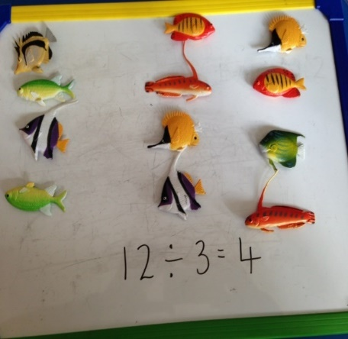
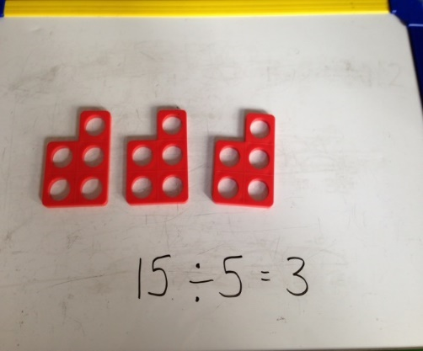

Draw the problem to help visualise the answer
Sharing the objects helps children to visualise the calculation.
Numicon visually supports children with the calculation too.

