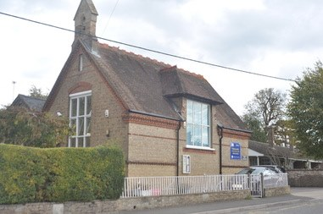
Marsworth School
Faith Newsletter
January 2022

Welcome to our first Faith Newsletter!
Our values this term are:
Perseverance ‘I can do all things through Him who strengthens me.’ Philippians 4:13
Justice ‘Learn to do right. Seek justice.’ Isaiah 1:17

In this edition of the newsletter
- The school prayer and the school's core Christian values
- The school's vision
- Community and living well together
- Celebrations
- Coming up in the next edition

OUR SCHOOL PRAYER
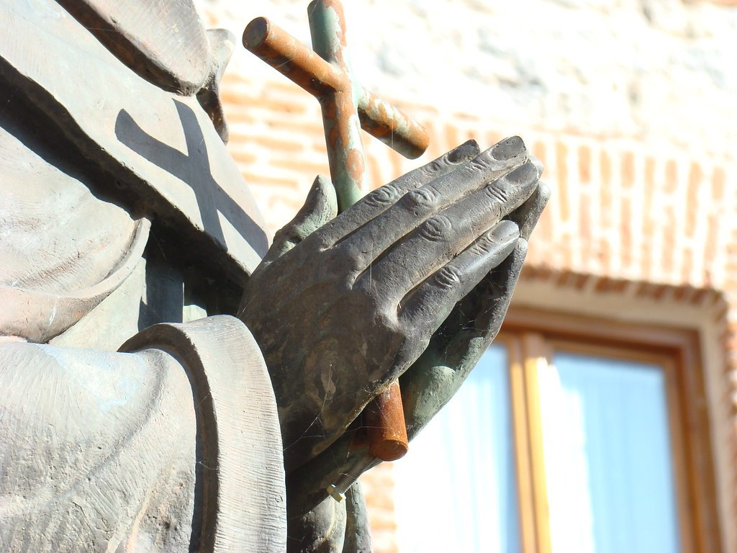
Below you will find a copy of our school prayer which is read in collective worship and will be said at events and celebrations. Please help your child to learn this and familiarise yourselves with it as you may be asked to join in!

Marsworth School Prayer
Dear God,
Teach us to show compassion towards others.
Help us to have courage to speak the truth and overcome our fears.
We will continue to show respect for all living things.
Guide us to be curious to help us learn as we grow.
Teach us how to live and we will remember it all our lives.
Amen



Our core school values are:

Courage- we try to encourage the children to try something new, to step out of their comfort zone and to engage in their learning and growth.

Curiosity- we firmly believe that curiosity is a key part for helping children grow and develop into inquisitive learners, emotionally, spiritually and academically.

Compassion- plays an integral role in how we live both as children and adults.

Respect- treating others how you wish to be treated is an important lesson, no matter how old you are.

OUR SCHOOL VISION


Through our values of RESPECT, COURAGE, COMPASSION and CURIOSITY, Marsworth C E Infant School provides a unique, nurturing environment to inspire a love of learning in our children.
‘Teach children how they should live, and they will remember it all their lives.’ Proverbs 22:6
We care for each child as an individual to support their education, social, spiritual and moral growth.

COMMUNITY AND LIVING TOGETHER

At Marsworth School we have always raised money for charities through fundraising events and cake sales. At Harvest we have supported local food banks by donating food items for those less fortunate than ourselves. We always try to learn about the charities we are supporting in our lessons and in Collective Worship. We would like to continue this by trying something new.
There are a few charities that are close to my heart such as the Scoliosis Association, the British Heart Foundation and the Stroke Association. I cannot be the only one who has charities both national and local that are meaningful to them. As a school we would like to support and learn more about charities that may have direct links to our community.
In order for us to do this we would like parents or family members to let a member of staff know of any charities that we could support. This list will then be shared each half term with the children and they will vote for the charity. Any fundraising events and donations will be for the chosen charity.
CELEBRATIONS AND EVENTS


CHINESE NEW YEAR 1st February 2022
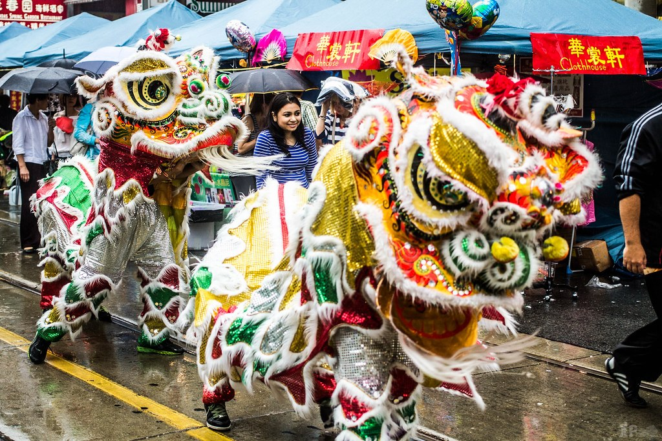 New Year’s Day is the most important event in the traditional Chinese calendar and marks the beginning of the first lunar month. The festival is colourfully celebrated with fireworks, dances (such as the famous Lion Dance) and the giving of gifts, flowers and sweets. Gold is a dominant colour to symbolise the wish for prosperity, and red is also much used as a lucky colour. Business accounts should be settled and all debts paid before the New Year begins. Celebrations can last three or more days. 2022, which is 4720 in Chinese culture, is the year of the Tiger, one of twelve symbolic creatures whose character is held to affect the nature of those born at this time.
Chinese New Year is actually celebrated for 15 consecutive days, but the first three days are most important. The 15th and final day is also a big event, where houses are decorated with an abundance of brightly coloured lights. It is a way of ending with a grand finale rather than the festivities just fading away gradually.

SHROVE TUESDAY- 1st March 2022
 Commonly known as Pancake Day, this is the day before the start of Lent. Traditionally it is a day for repentance and absolution in preparation for Lent (‘shrive’ means to receive or make confession). Pancakes were originally made to use up all the rich foods, such as butter and eggs, before Lent. In some parts of the world people celebrate Mardi Gras (Fat Tuesday) by holding carnivals

THE PROPHET’S NIGHT JOURNEY AND ASCENT/LAILAT (LAYLAT) UL ISRA WA-L-MIRAJ- 1st March 2022
 This festival celebrates the journey of the Prophet Muhammad, in the tenth year of his prophethood, from Makkah to Jerusalem, and through the heavens to the presence of God, all in one night. On this night Muslims believe the Prophet received the command that they should pray five times each day. The rock in Jerusalem from which the Prophet ascended is now contained in the Dome of the Rock. Muslims mark this night by reading the Qur’an and saying additional prayers. The following day is accordingly a day for recuperation rather than one for physical activity.

ASH WEDNESDAY 2nd March 2022
 The first day of Lent when Christians remember the forty days that Jesus spent in the wilderness and the temptations he faced during this time. In Catholic and some Anglican churches, services are held where the worshipper’s forehead is marked with a cross of ash, which has been made from burning the palm crosses of the previous year – hence the name Ash Wednesday.

MOTHERING SUNDAY (Simnel Sunday) 27th March 2022
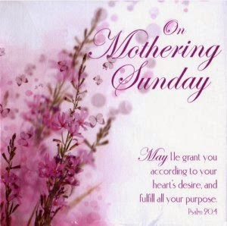 Mid-Lent Sunday, the 4th Sunday in Lent, has now become secularised and is more popularly known as Mother’s Day. It was, traditionally, a Sunday when Christians revisited their ‘mother church’ and took gifts to their mothers, which often included a simnel cake.

HALF TERMLY CELEBRATION SERVICE
Starting after half term we will be reinstating our half termly celebration service. This will take place in the church on last day of each half term. Parents are welcome to join us. In previous years’ children and staff have been awarded certificates for their hard work and their learning. The children will have helped plan this service by choosing the songs, bible readings and prayers. We do hope you will be able to join us.

NEXT EDITION
 Coming up next time we will be focusing on Collective Worship and Religious Education and Diversity.


Marsworth Infant school
Vicarage Road
Marsworth Nr Tring Hp23 4LT
01296 668440
office@marsworth.buck.sch.uk
Visit us on the web at https://www.marsworthschool.co.uk/

