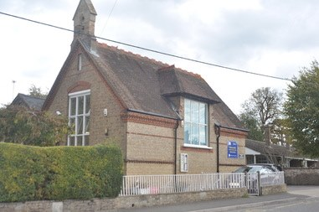

Marsworth School
Faith Newsletter
May 2022
2nd Edition
Our values this term are:
Thankfulness ‘Always be thankful’ 1 Thessalonians 5.6
Service 'Serve one another in love’ Galatians 5.13
In this edition of the newsletter
- Collective Worship
- Religious Education
- Celebrations
- School Prayer
- Coming up in the next edition

 Collective Worship
Collective Worship gives pupils and school staff the opportunity to:
- Engage in an act of community
- Express praise and thanksgiving to God
- Be still and reflect
- Explore the big questions of life and respond to national events
- Foster respect and deepen spiritual awareness
- Reflect on the character of God and on the teachings of Christ
- Affirm Christian values and attitudes
- Share each other's joys and challenges
- Celebrate special times in the Christian calendar and of other faiths

Collective Worship at Marsworth School is invitational as we have hymns and songs playing on entry, we light three candles with reference to the Trinity. We also say a range of call and responses. The children are becoming more actively involved in the planning and delivery of Collective Worship. For example, they planned and delivered the first celebration service, the Mothering Day service and the May Day Celebration.
There are opportunities for children to reflect about the stories they have read and about events that have taken place, should they wish they can share their thoughts and ideas with everyone. We read prayers and create our own prayers often linked to the values of the term or the school's core values. The children find out about other faiths and listen to stories from other faiths. We make links to the Bible and sing hymns and songs.
The pupils have reviewed the current process of collective worship through pupil voice (school council) and have suggested improvements for how we can make Collective Worship even better and more engaging. Some of which we will be implementing this term.

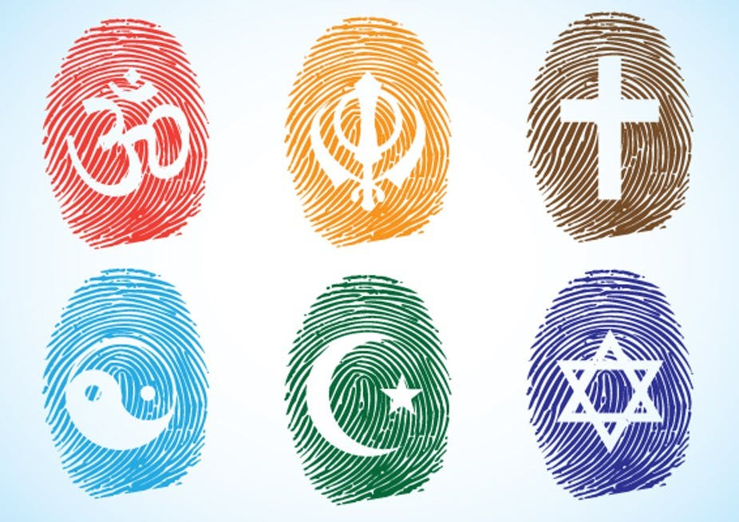 Religious Education

Religious Education is expected to be taught for 36 hours per academic year (1 hour per week for EYFS and KS1). As a church school, Christianity is at least 50% of the curriculum with the opportunity for other faiths to be studied.
At Marsworth School in KS1, we follow the Oxford Diocese Board of Education Scheme of Work which is enhanced with the use of Understanding Christianity.
Understanding Christianity:
- Develops pupils' own thinking and understanding of Christianity
- Explores the significant theological concepts within Christianity as part of developing pupils wider religious, theological and cultural literacy
- Supports teachers in developing their own knowledge and understanding of Christianity theology to be able to teach with confidence
Other faiths are also studied, such as Judaism and Islam. The children learn about special places, special books and different and similar festivals. They also learn about stories from the Bible and from other faiths.
In EYFS the children have exposure to a variety of different stories from the Bible and from other faiths. The key focus for Christianity is The Creation, The Incarnation (birth of Christ, Christmas) and The Salvation (death/rebirth of Christ, Easter).
The children learn about these key events through stories, drama, artwork, songs and carrying out practical activities.
As children enter Key Stage 1, the children will be presented a Bible which they are required to keep in their desk as they may need to use it in their RE lessons. When leaving the school at the end of Year 2, they will be able to take it home with them as a reminder of their time at Marsworth School.
Further information about RE in a church school can be found via the RE Statement of Entitlement produced by the Church of England.
RE Statement of Entitlement document can be found via the link below:
https://www.churchofengland.org/sites/default/files/2019-02/RE%20Statement%20of%20Entitlement%20for%20Church%20Schools.pdf

 CELEBRATIONS AND EVENTS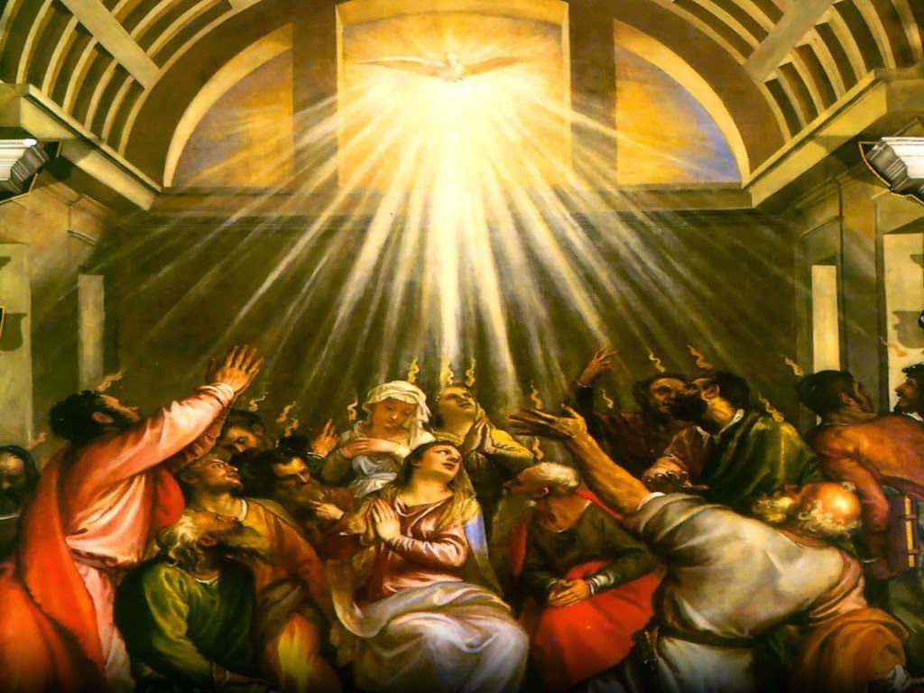 Whit Sunday (Whitsun /Pentecost) 5th June 2022
Whitsun or Whit Sunday is the name used in Britain and throughout the World.
As recorded in the New Testament of the Bible, it was on the 50th day after Easter that the apostles were praying together and the Holy Spirit descended on them. They received the "gift of tongues", the ability to speak in other languages and immediately began to preach about Jesus Christ to Jewish people from all over the World who flocked to Jerusalem for the Feast of Shavuot.
Christian Pentecost became not only a commemoration of the Holy Spirit's visit, but also marks the birth of the Christian Church. Although it is not certain when Pentecost began to be observed by Christians, it may have been early as the first century. Whitsuntide, also referred to as Whitsun in modern times, is the period beginning with the Saturday before Whitsunday and ending the following Saturday.
According to church tradition, Pentecost is always about seven weeks after Easter Sunday, or 50 days after Easter, including Easter Day.
The symbols of Pentecost are those of the Holy Spirit and include flames, wind, the breath of God and a dove. In many parts of the World, Pentecost has become a traditional day for baptisms to take place. On this day, many people enjoy family gatherings, picnics, or outings to the country.
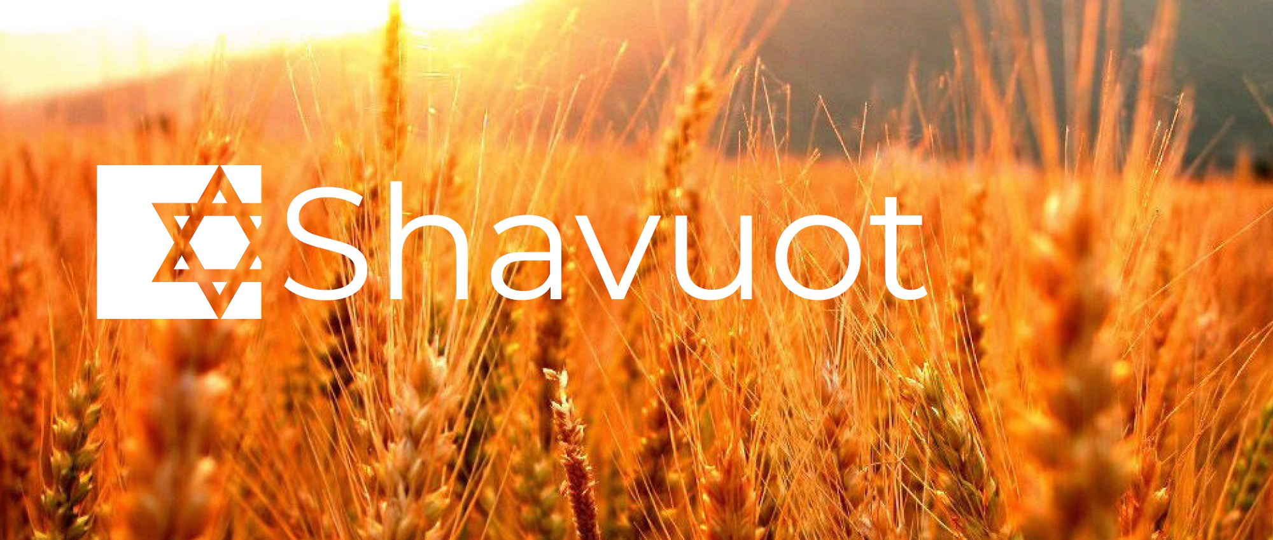 Shavuot 5th June 2022
Shavuot, or Shavuos (also known as Pentecost), is one of the most important holidays on the Jewish calendar.
Shavuot falls seven weeks after Passover at the end of the counting of the Omer (a verbal counting of each of the 49 days between the Jewish holidays of Passover and Shavuot).
The holiday celebrates the giving of the Torah on Mount Sinai as well as the grain harvest for the summer. In biblical times, Shavuot was one of three pilgrimage festivals in which all the Jewish men would go to Jerusalem and bring their first fruits as offerings to God.
Today, Shavuot is celebrated by going to synagogue to hear the 10 Commandments, having festive meals of dairy foods, staying up all night to learn and reading the Book of Ruth.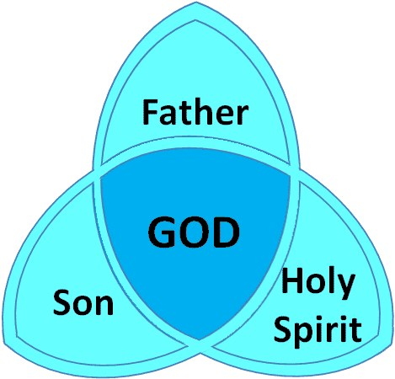 Trinity Sunday 12th June 2022

Many Christians in the United Kingdom celebrate Trinity Sunday, which is the first Sunday after Pentecost. It is one of the few feasts that are celebrated as a doctrine instead of an event. It is also symbolic of the unity of the Trinity.
Many Christian churches in the United Kingdom observe Trinity Sunday through various activities, including special church services that focus on the theme of the trinity. Such services give the congregation a chance to learn about or revisit the concept of the trinity, which refers to the Father, Son and Holy Spirit being one God.
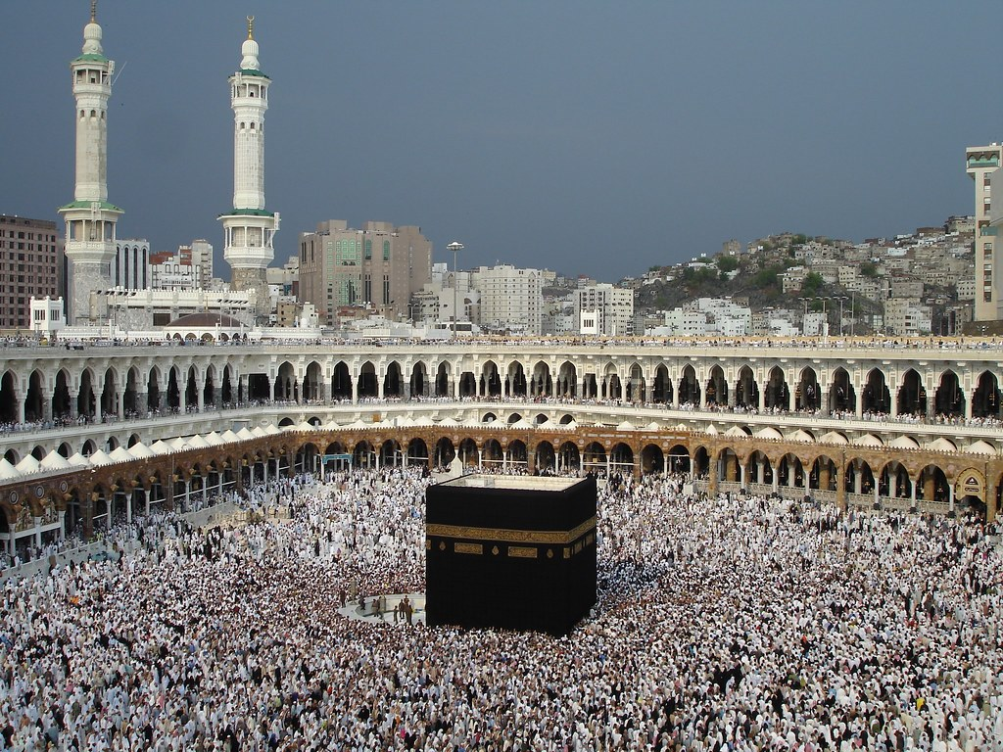 Hajj Day
Rituals of Hajj 2022 will commence from the evening of Thursday, 7th of July 2022 and will continue until the evening of Tuesday, 12th of July 2022. This is the tentative date as the actual date is contingent on the sighting of the moon of Dhul Hijjah, 1443, the 12th and last month of Islamic Calendar.
Hajj (حَجّ‎) is an Arabic word which means ‘Aim’ or ‘Destination’ or ‘Purpose’. Hajj is the ultimate journey to the House of Allah (Kaaba).
Hajj is one of the five pillars of Islam. Hajj involves travel and it requires more effort than other kinds of worship. This is the reason that Allah has only made it mandatory for his servants to perform it only once in a lifetime with the stipulation that one must be able to do it both financially and physically.
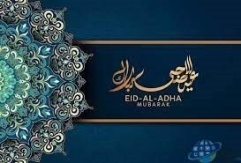 Eid-al-Adha 9th July 2022
Eid ul-Adha ('Festival of Sacrifice') is one of the most important festivals in the Muslim calendar. The festival remembers the prophet Ibrahim's willingness to sacrifice his son when God ordered him to. Eid ul-Adha is a public holiday in Muslim countries. In 2022, Eid ul-Adha will begin on the evening of Saturday 9 July and end on the evening of Wednesday 13 July.
Eid ul-Adha celebrates the time when Ibrahim had a dream which he believed was a message from Allah asking him to sacrifice his son Isma'il as an act of obedience to God. The devil tempted Ibrahim by saying he should disobey Allah and spare his son. As Ibrahim was about to kill his son, Allah stopped him and gave him a lamb to sacrifice instead.
In some countries, Muslims sacrifice a sheep or goat (in Britain the animal is killed at a slaughter house). The meat is shared equally between family, friends and the poor.
Eid usually starts with Muslims going to the Mosque for prayers. They dress in their best clothes and thank Allah for all the blessings they have received. It is a time when they visit family and friends. Muslims will also give money to charity so that poor people can celebrate too.
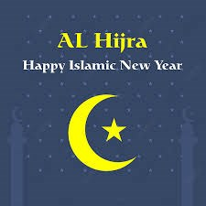 Al- Hijra Islamic New Year 30th July 2022
Al-Hijra is a Muslim festival that marks the first day of the Islamic calendar. It commemorates the journey Muhammad and his followers took from Mecca to Medina in 622 CE.
In the year 622 CE, the Prophet Muhammad and a number of his followers moved from Makkah/Mecca to the city of Medina and set up the first Islamic state there. Their arrival marked the beginning of Islam as a community in which spiritual and earthly life were completely integrated. They were a group inspired by and totally obedient to God, bound together by religious faith. By breaking the link with his own tribe the Prophet demonstrated that tribal and family loyalties were insignificant compared to the bonds of Islam.
For some Muslim communities this is a day of celebration at the mosque, where stories are told of the Prophet and his Companions. There are no special religious rituals required at this time but a special prayer service is normally held in the mosque and afterwards people wish one another a Happy New Year. On this day Muslims think about the meaning of the Hijra and regard this as a good time for new year resolutions, relating to their following of the example of the Prophet.
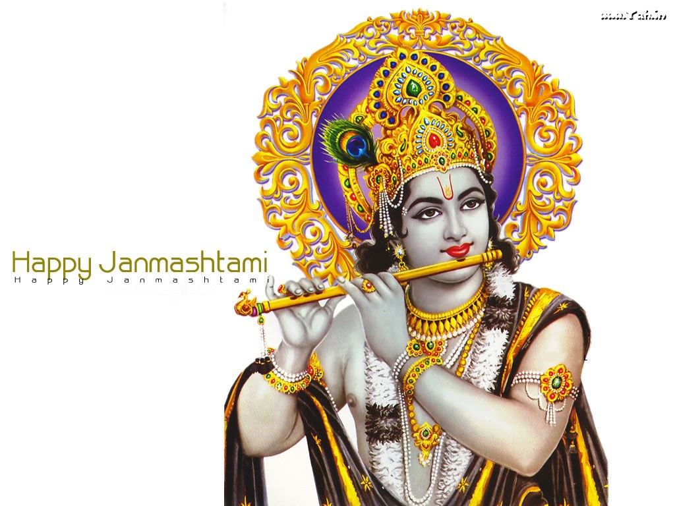 Krishna Janamashtami 19th August 2022
The Krishna Janmashtami festival marks the birth of Krishna, one of the most popular deities worshipped by Hindus. He is thought to have been born in 3228 BC.
His birthday is celebrated eight days after Raksha Bandhan, a festival celebrating the bond between brothers and sisters. It falls in the Hindu month of Sravana, which normally corresponds to August or September. Celebrations are spread over two days and are vibrant and passionate.
Festivities start at midnight, when Krishna is thought to have been born.
Celebrations are different all over India, where each region has its own way of marking the special occasion. In the UK, one of the biggest celebrations for Janmashtami is held at Bhaktivedanta Manor in Hertfordshire. Thousands of plates of prasadam, a sacred vegetarian food, are given away to visiting pilgrims.
Some Hindus simply don't go to sleep during the celebrations and instead sing bhajans, traditional Hindu songs. Food is a key ingredient for Janmashtami: Krishna is thought to have favoured milk and curds, so meals are prepared from these ingredients. However, some Hindus choose to fast all day and night for the first day of Krishna Janmashtami, breaking the fast at midnight.
Song, dance and drama are essential to the lively and colourful celebrations. Plays are carried out re-enacting scenes from Krishna's early life. In temples, images of Krishna are bathed and placed in cradles, whilst the shankh (conch shell) is blown and bells are rung. Holy mantras are also chanted to venerate him.

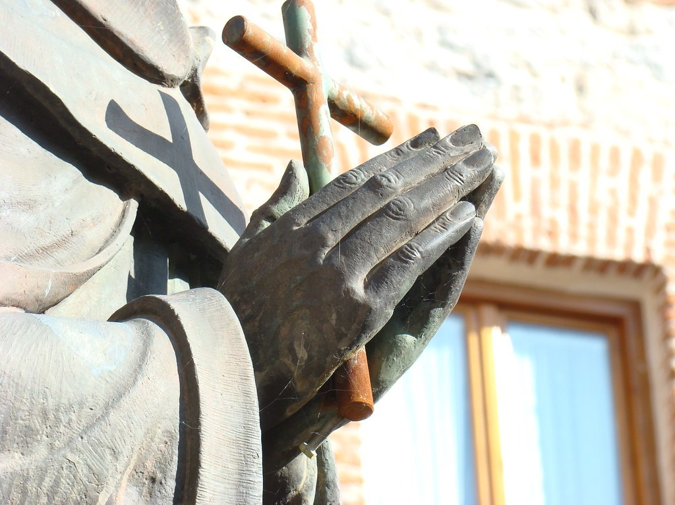 OUR SCHOOL PRAYER
Below you will find a copy of our school prayer which is read in collective worship and will be said at events and celebrations. Please help your child to learn this and familiar yourselves with it as you may be asked to join in!

Marsworth School Prayer
Dear God,
Teach us to show compassion towards others.
Help us to have courage to speak the truth and overcome our fears.
We will continue to show respect for all living things.
Guide us to be curious to help us learn as we grow.
Teach us how to live and we will remember it all our lives.
Amen

 NEXT EDITION

Coming up next time we will be focusing on:
- Our school vision and what it really means
- Harvest

Marsworth Infant school
Vicarage Road
Marsworth
Hp23 4LT
01296 668440
office@marsworth.buck.sch.uk
Visit us on the web at https://www.marsworthschool.co.uk/

