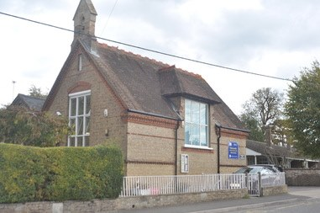

Marsworth School
Faith Newsletter
December 2022
3rd Edition
Our values this term are:
Generosity –‘ God loves a cheerful giver’ 2 Corinthians 9.7
Compassion – ‘Clothe yourselves with compassions, kindness, humility, gentleness and patience.’ - Colossians 3.12

In this edition of the newsletter
- The School’s Vision
- School Prayer
- Harvest
- Celebrations and events
- Coming up in the next edition

The School’s Vision
Through our values of Respect, Courage, Compassion and Curiosity, Marsworth CE Infant School provides a unique, nurturing environment to inspire a love of learning in our children.
‘Teach children how they should live, and they will remember it all their lives.’ Proverbs 22:6
We care for each child as an individual to support their education, social, spiritual and moral growth.
We strongly believe that we are the foundations of children’s learning and that we play an integral part of children’s development and growth. Creating positive learning experiences for all children to succeed is paramount.

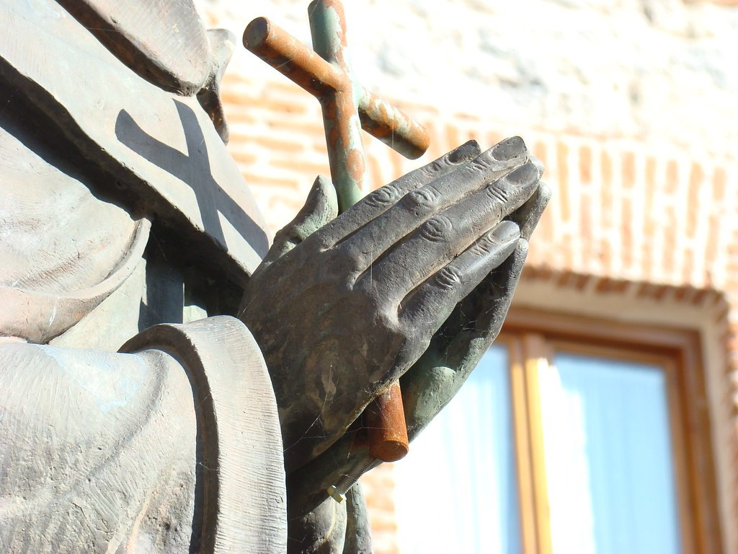 OUR SCHOOL PRAYER
Below you will find a copy of our school prayer which is read in collective worship and will be said at events and celebrations. Please help your child to learn this and familiar yourselves with it as you may be asked to join in!

Marsworth School Prayer
Dear God,
Teach us to show compassion towards others.
Help us to have courage to speak the truth and overcome our fears.
We will continue to show respect for all living things.
Guide us to be curious to help us learn as we grow.
Teach us how to live and we will remember it all our lives.
Amen

Harvest
This year the school took part in the Harvest service at the church. The children learnt and performed a song called the Harvest Samba. They also wrote and recited a harvest prayer. It was lovely to be part of the community once again and to help donate to the local food bank. The special time of year linked nicely to learning about the values of compassion and generosity. The children also learnt about harvest around the world and how and when it is celebrated for example in Canada they have thanksgiving on the second Monday in October. In USA it is celebrated on the fourth Thursday in November.

 CELEBRATIONS AND EVENTS

Advent 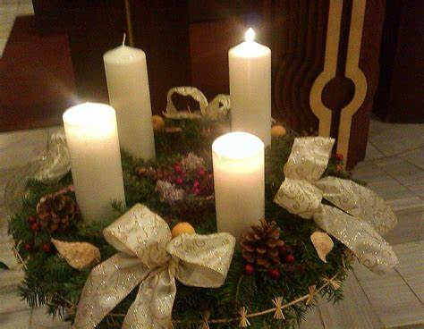
Advent is an important part of the Christian calendar.
It means 'coming' and it's the period before Christmas which celebrates the birth of Jesus.
It is all about preparing for Christmas Day. Advent starts on the Sunday nearest to 30 November - four weekend's before Christmas.
So in 2022, it actually started on Sunday 27 November and will be observed until Friday 24 December.
Many Advent customs involve counting down the days until Christmas begins.
Some churches have an advent wreath with five candles, one for each of the four Sunday's leading up to Christmas Day and one for Christmas Day itself.
Sometimes Christians will have their own Advent candle which they'll burn at home. This burns down gradually as each day passes toward the big day itself.
Many people who aren't Christians also look ahead to Christmas by having an advent calendar.
As a school we took part in the village living advent calendar. This is where properties in the village decorated a window on a a different day on chritsmas theme and then lit it up at night. Marsworth ce infant school was day nine. This was our display.

Christmas 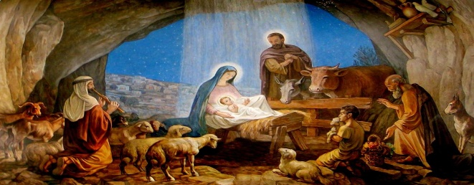
Christmas is a Christian holy day that marks the birth of Jesus, who Christians believe to be the Son of God.
Jesus was born to a woman called Mary who was engaged to Joseph, a carpenter in the town of Nazareth in Galilee.

Mary was visited by an angel who told her that she would give birth to a baby called Jesus. Jesus was born in Bethlehem because Joseph and Mary had travelled there to take part in a census which the Roman rulers had ordered.

When Mary and Joseph arrived in Bethlehem the local inn was full with people returning for the census. The innkeeper let them stay in the rock cave below his house which was used as a stable for animals. It was here that Mary gave birth to Jesus.
Jesus was visited by three wise men from the East who had followed a star to Bethlehem. The wise men presented Jesus with gifts of gold, frankincense and myrrh. An angel also guided some poor shepherds to see the birth. For Christians this shows that Jesus came for all people of all backgrounds.

Hannuakah 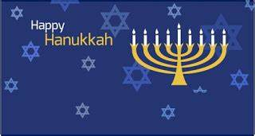
Hanukkah is the Jewish Festival of Lights. The word 'Hanukkah' means 'Dedication' in Hebrew. It celebrates a miracle that happened in Jerusalem over 2,000 years ago.
Hanukkah (or Chanukah in Hebrew) is celebrated in November or December every year. It lasts for eight days.
This year Hanuakkah began Sunday, 18 December at sunset and ends Monday, 26 December at nightfall.

A long time ago a Syrian king called Antiochus banned the Jews from worshiping God. He put a big statue of himself in their temple and ordered them to bow before it. However, the Jews refused to obey him because the Ten Commandments forbid them to worship anyone other than God . A small group of Jews called the Maccabees fought back against the kings army. After three years, they won the war and recaptured Jerusalem from the Syrians. When the Jews went back to their temple, they saw that it had nearly been destroyed. They cleaned and repaired the temple. When they were finished, they rededicated it to God. They did this by lighting the lamp, which was a symbol of God's presence. They only had one small jar of oil which was only enough for one day. However, miraculously the lamp stayed alight for eight days! That is why Jews light a candle every day of Hanukkah.
New Year / Hogmanay
31st December 2022
A celebration widely observed throughout the UK, and especially in Scotland, where bagpipes, haggis and first footing are widespread. Clearing one’s debts, cleaning the house, welcoming guests and strangers and a host of other traditions feature at this

 NEXT EDITION

Coming up next time we will be focusing on:
- New Year
- Easter
- RE in EYFS


Marsworth Infant school
Vicarage Road
Marsworth
Hp23 4LT
01296 668440
office@marsworth.buck.sch.uk
Visit us on the web at https://www.marsworthschool.co.uk/

