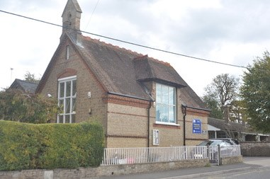
Marsworth School
Faith Newsletter
May 2023
4th Edition
Our values this term are:
Thankfulness ‘Always be thankful’ 1 Thessalonians 5.6
Service 'Serve one another in love’ Galatians 5.13

In this edition of the newsletter
- The school prayer and the school's core Christian values
- The School's Vision
- Collective Worship

- Religious Education and Diversity
- Celebrations and Events
- Coming up in the next edition

OUR SCHOOL PRAYER
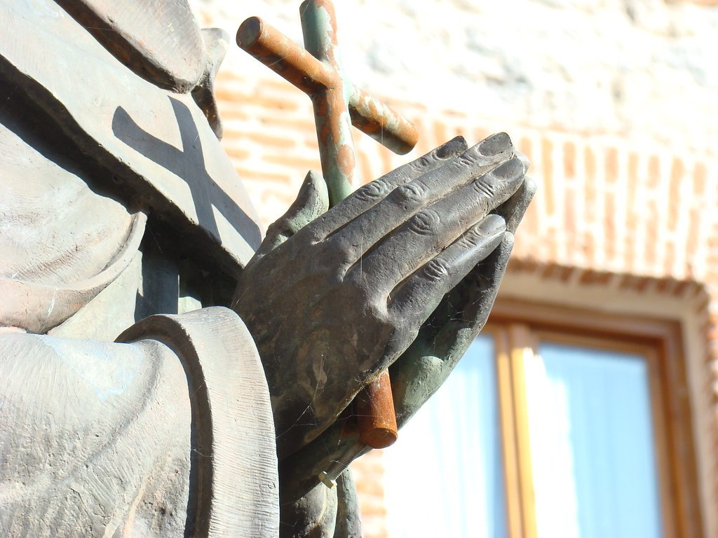
Below you will find a copy of our school prayer which is read in collective worship and will be said at events and celebrations. Please help your child to learn this and familiarise yourselves with it as you may be asked to join in!

Marsworth School Prayer
Dear God,
Teach us to show compassion towards others.
Help us to have courage to speak the truth and overcome our fears.
We will continue to show respect for all living things.
Guide us to be curious to help us learn as we grow.
Teach us how to live and we will remember it all our lives.
Amen

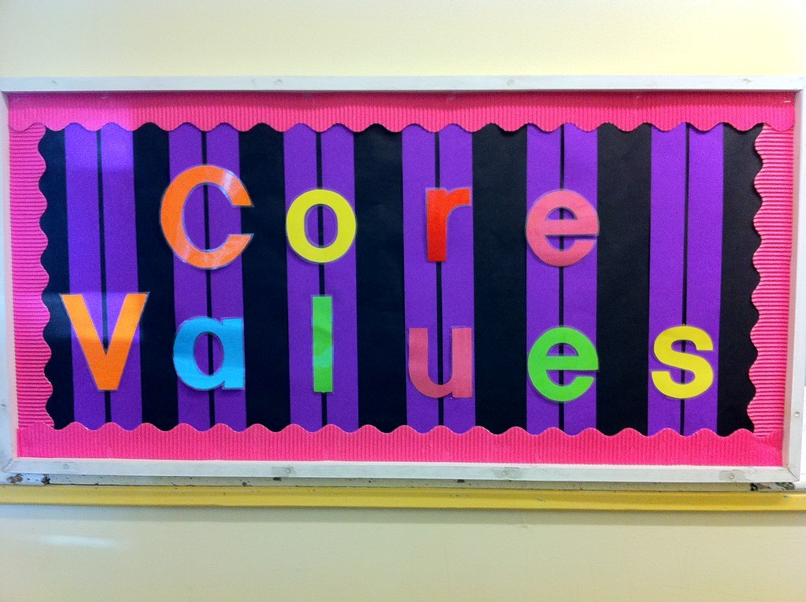

Our core school values are:

Courage- we try to encourage the children to try something new, to step out of their comfort zone and to engage in their learning and growth.

Curiosity- we firmly believe that curiosity is a key part for helping children grow and develop into inquisitive learners, emotionally, spiritually and academically.

Compassion- plays an integral role in how we live both as children and adults.

Respect- treating others how you wish to be treated is an important lesson, no matter how old you are.

OUR SCHOOL VISION


Through our values of RESPECT, COURAGE, COMPASSION and CURIOSITY, Marsworth C E Infant School provides a unique and nurturing environment to inspire a love of learning in our children.
‘Teach children how they should live, and they will remember it all their lives.’ Proverbs 22:6
We care for each child as an individual to support their education, social, spiritual and moral growth.
LEARN LIVE REMEMBER


COLLECTIVE WORSHIP
The children participate in daily acts of worship. These can be held at different times of the day. Sometimes it is held first thing in the morning, sometimes it can be straight after lunch it can also be held just before the children go home.
Collective Worship at Marsworth School is invitational as we have hymns and songs playing on entry, we light three candles with reference to the Trinity. We also say a range of call and responses. The children listen to bible stories and stories for other faiths. They have the opportunity to discuss the stories and the messages behind them and how they can have an impact on our lives today, often linking them to the values of the term.
For some time now, the children have been planning and leading the celebration services. Thank you for attending them, it is lovely to see so many family members be part of the school community and celebrate everyone’s successes.
The children are also invited to participate in a moment of stillness and reflection by listening to prayers, some of which the children themselves create and recite. This is invitational and not enforced upon.
RELIGIOUS EDUCATION AND DIVERSITY

In Church of England schools, where pupils and staff come from all faiths and none, religious education (RE) is a highly valued academic subject that enables understanding of how religion and beliefs affect our lives. At the heart of RE in church schools is the teaching of Christianity and pupils also learn about other faiths and world views.
RE plays a central role in a broad and balanced curriculum that will enable students to participate fully in a multi-religious and multi-secular world. It provides opportunities for children to feel safe to explore and express their views and learn to respect others thoughts too. It helps them to make informed decisions about the wider world.
Here at Marsworth school we follow the ODBE (Oxford Diocese Board of Education) RE scheme of work, we enhance this further by using the Understanding of Christianity syllabus.
In EYFS the key focus is the creation, the birth and death of Jesus. In KS1 the same units are revisited and along with learning about bible stories, leadership and key events such as baptisms. The children are also taught about Judaism. As we have a couple of Muslim families the children learn about stories from Islam. They are able to make comparisons about special books - the Bible, Tora, the Quran and places of worship, Churches, Mosques, temples and Synagogues.
Further information about the scheme and units covered will be uploaded to the school website under the SIAMS and RE tab.
CELEBRATIONS AND EVENTS

25th – 27th May - Shavuot: This Jewish holiday celebrates the giving of the Torah on Mount Sinai and a grain harvest
4th June – Pentecost - Christian (Orthodox): An important festival in the Christian year, Pentecost is often seen as the ‘birthday’ of the Church, since this is when the disciples of Jesus first proclaimed the Gospel after receiving the gift of the Holy Spirit. It is named after the Jewish festival day on which this event happened.
4th June - Trinity Sunday: On Trinity Sunday, Christians reflect on the mystery of God, who is seen as One but is understood in and through God, the Father, God, the Son, and God, the Holy Spirit.
22nd June - DUANWUJIE / TUAN YANG CHIEH [Dragon Boat Festival] Chinese: Great dragon boat races take place between slim rowing boats (sometimes 100 feet long) shaped like dragons. People also go down to the rivers to picnic and celebrate on boats.
26th June - 1st July - The Hajj: Among the most important of Muslim holy days. This annual pilgrimage to the holy city of Mecca that’s required for all Muslims during their lifetime if they are financially and physically able to do it.

28th June to 2nd July – Eid al-Adha: A holiday in the Islamic faith that ends the Hajj pilgrimage- Festival of the Sacrifice. This major festival (al-Eid al-Kabir) commemorates Ibrahim’s (Abraham’s) willingness to sacrifice his son, Ismail. Muslims all over the world sacrifice an animal if they can afford it. Much of the meat is distributed to the poor and some is shared with relatives and friends.
7th July - EID UL GHADEER / EID-UL-GHADIR [Festival of The Pool] Muslim (Shi‘a): This is a festival observed by Shi‘a Muslims, for whom it is an extremely important day. It commemorates an event shortly before the death of the Prophet and his announcement concerning Ali, which they understand to be his clear appointment to be successor to the prophet as the spiritual and temporal leader of Islam.
13th - 15th July - O-BON Japanese: (Eastern Japan, including Tokyo. Elsewhere in Japan, celebrated in August).
A Japanese festival when the spirits of the departed are welcomed back home with feasting and dancing. Fires are often lit to illuminate their arrival and departure.

27th July - TISHA B'AV Jewish:
Full day fast mourning the destruction of the first and second Temples in Jerusalem and other tragedies in Jewish history. The Book of Lamentations is read.

NEXT EDITION

Coming up next time we will be focusing on SIAMS, Character Development: Hope, Aspiration, and Courageous Advocacy.


Marsworth Infant school
Vicarage Road
Marsworth, Nr Tring
Hp23 4LT
01296 668440
office@marsworth.buck.sch.uk
Visit us on the web at https://www.marsworthschool.co.uk/

