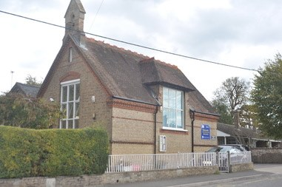
Marsworth School
Faith Newsletter
March 2024
5th Edition
Our value this term is: Hope
‘May the God of Hope fill you with joy and peace.’ Romans 15.13

In this edition of the newsletter
- The school prayer and the school's core Christian values
- The school's vision
- Personal development and aspiration
- Curriculum events
- Spirituality
- Celebrations and events
- Coming up in the next edition

OUR SCHOOL PRAYER
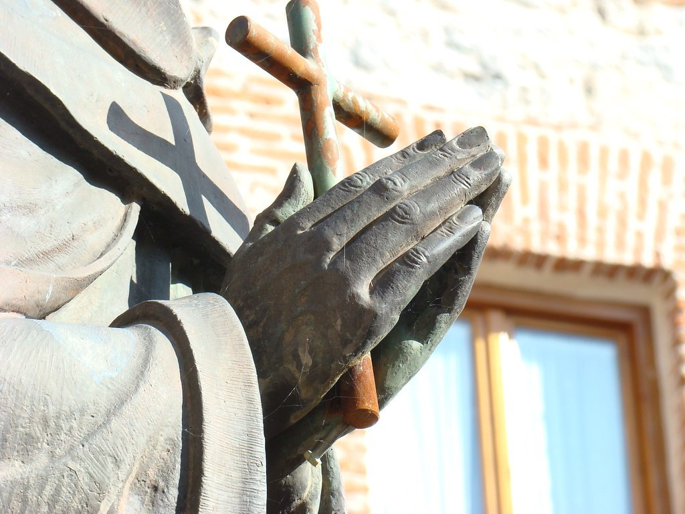
Below you will find a copy of our school prayer which is read in collective worship and will be said at events and celebrations. Please help your child to learn this and familiarise yourselves with it as you may be asked to join in!
Marsworth School Prayer
Dear God,
Teach us to show compassion towards others.
Help us to have courage to speak the truth and overcome our fears.
We will continue to show respect for all living things.
Guide us to be curious to help us learn as we grow.
Teach us how to live and we will remember it all our lives.
Amen

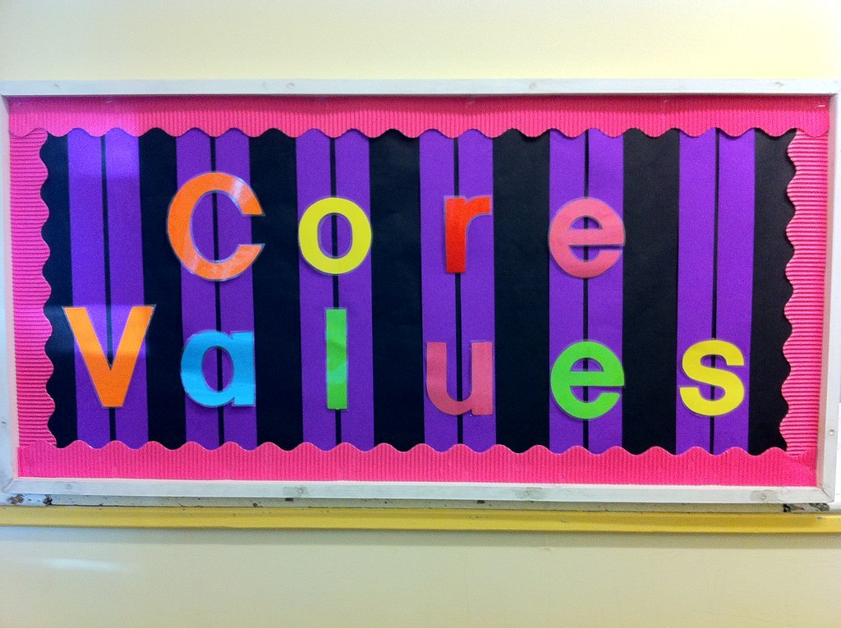

OUR SCHOOL VALUES:

Courage - we try to encourage the children to try something new, to step out of their comfort zone and to engage in their learning and growth.

Curiosity - we firmly believe that curiosity is a key part for helping children grow and develop into inquisitive learners, emotionally, spiritually and academically.

Compassion - plays an integral role in how we live both as children and adults.

Respect - treating others how you wish to be treated is an important lesson, no matter how old you are.

OUR SCHOOL VISION


Through our values of RESPECT, COURAGE, COMPASSION and CURIOSITY, Marsworth C E Infant School provides a unique and nurturing environment to inspire a love of learning in our children.
‘Teach children how they should live, and they will remember it all their lives.’ Proverbs 22:6
We care for each child as an individual to support their education, social, spiritual and moral growth.
LEARN LIVE REMEMBER

PERSONAL DEVELOPMENT AND ASPIRATION
Our intent at Marsworth CE Infant school is to support children throughout their early stages of life. Teaching them to live respectfully, compassionately, courageously and curiously through a clearly designed and well thought out curriculum, but also giving them opportunities to develop personally and giving them hope for the future.
We no longer give children weekly homework but expect all children to read regularly at home, reading is a life skill and is the one of the foundations of life.
Another activity is the Junior Duke Award. The school has paid for children to complete the Micro, Mini or Junior Duke awards. This gives children opportunities to complete fun and engaging life skill tasks. It has been lovely to see the children who have been completing it be more engaged in the world around them and develop in confidence. They beam with delight and are proud of what they have achieved. The award does continue into KS2. It provides the children with a taster of the Duke of Edinburgh Award, should they aspire to continue with it as they grow.
Being in an area where there are many bodies of water, we believe that being able to swim and have water confidence is an integral part of life. Being able to take the children from such a young age every week to Aqua Vale for their swimming lessons, helps to embed these important life skills. Not only do they learn how to swim and learn about water safety, they are also learning to support others, to develop empathy and compassion for their peers. They develop fine and gross motor skills along with independence when changing for swimming. For some this is often their first experience of being in a pool. To see the children on their journey having courage and overcoming their fears is amazing and I know myself and the staff are extremely privileged to be part of it.

CURRICULUM EVENTS 
In KS1, Rev. James came in to talk to the children about Baptism. The children learnt about the symbols, promises and blessing aspects of a Baptism service. They also learnt how the oil, water and the Baptism candle are used. The children then followed this up with some work for a display as part of the unit of ‘Belonging’.
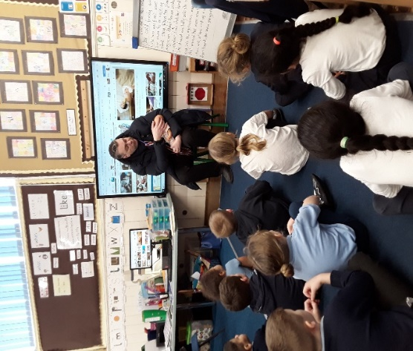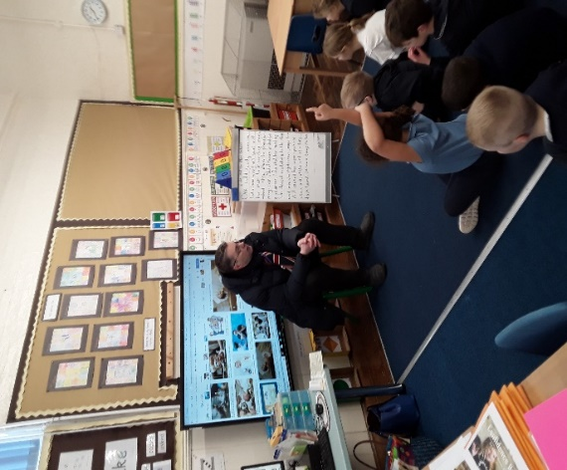
Baptising a baby Q &A session
The curriculum is also designed for children to develop an awareness and understanding of different religions and faiths. We are fortunate to live in such a diverse world, we wanted to celebrate this and by welcoming Mrs Chaudhry from the Muslim community in Aylesbury. She spoke to the children about Islam and the holy book called the Quran. She showed them a prayer mat. Ramadan had not long started so she explained to the children why she was fasting. The talk also included information about the Five Pillars of Islam and the six steps that Muslims should follow to live a good life. The children enjoyed finding out about the Quran and links to the Old Testament in the Bible. Mrs Chaudhry was very impressed with the children’s knowledge and how keen they were to want to know more. She enjoyed answering the children’s questions.
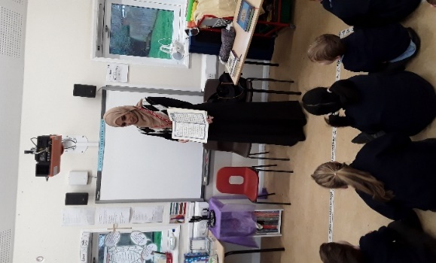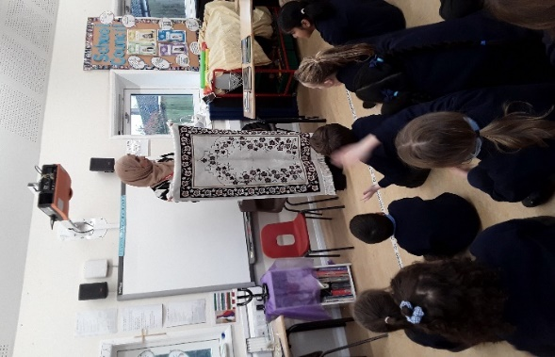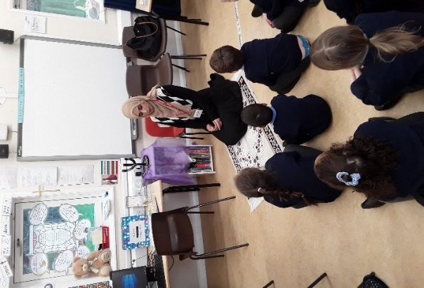
The Quran A Prayer Mat
Thank you to Mrs Chaudhry for giving up her time to come and visit us here at Marsworth School and thank you to Mrs Farooq who also helped to organise the visit.
SPIRITUALITY
An area that we have been working on developing and refining in school is spirituality. Meetings have taken place with staff and governors about what spirituality means for us at Marsworth school and how it is embedded within the school, not only within the curriculum, but in day to day life.
I held a school council meeting with all children, to obtain their views and thoughts. Our next step is to find out the views from parents. Over the past week or so, you should have received an email with a link to an anonymous online parent SIAMS questionnaire. Please could you spare five to 10 minutes completing it. Once all information has been collated it will be shared on the school website and in the next newsletter. Thank you for your continued support.

 CELEBRATIONS AND EVENTS

Ramadan begins on 10th March
Ramadan is a period of ritual fasting. It marks the time when the Quran (their holy book) was revealed to the Prophet Muhammad (PBUH). During Ramadan, most Muslims fast. This means they are not allowed to eat or drink during daylight hours. When fasting, they feel hungry and thirsty, which reminds Muslims of people in the world who are less fortunate than themselves. They begin to understand what it must be like for people who don’t have much to eat and because of this, many give money to the poor. Muslims will often have a meal called ‘Suhoor’, before sunrise and another called ‘Iftar’ after sunset.

St. Patrick’s Day 17th March
Millions of people around the world celebrate St. Patrick's Day on 17th March every year. It is a celebration of Irish history and culture and is a national holiday in the Republic of Ireland and Northern Ireland.
St. Patrick is the patron saint of Ireland and is celebrated for bringing Christianity to the country.

Palm Sunday 24th March
Christian churches all celebrate Palm Sunday, which is the beginning of Holy Week. Palm Sunday commemorates when Jesus entered Jerusalem and was greeted by people waving palm branches. This event serves as a reminder for Christians to welcome Jesus into their hearts and be ready to follow Him.

Holi 24th to 25th March
Holi marks the arrival of spring and the end of winter. It is usually celebrated in March. Holi is a Hindu festival that celebrates spring, love and new life. Some families hold religious ceremonies, but for many Holi is more a time for fun. It's a colourful festival, with dancing, singing and throwing of powder paint and coloured water. Holi is also known as the "festival of colours". Holi also celebrates the Hindu God Krishna and the legend of Holika and Prahlad.

Easter - Maundy Thursday 28th March, Good Friday 29th March, Holy Saturday 30th March and Easter Sunday 31st March
Easter is the most important festival in the Christian calendar. It celebrates Jesus rising from the dead, three days after he was executed. The week leading up to Easter is called Holy Week. The date of Easter Sunday varies from year to year. It is celebrated on the first Sunday after the full moon, on or after 21st March.

Maundy Thursday
This is the Thursday before Easter Day. On Maundy Thursday, Christians remember when Jesus ate the Passover meal with his disciples, breaking bread and drinking wine. Christians refer to this meal as the ‘Last Supper’. Many Christians remember the ‘Last Supper’ by sharing bread and wine together in a church service called Holy Communion, Eucharist or Mass. It is a reminder that Jesus sacrificed his life for mankind.

Good Friday
Good Friday is the Friday before Easter Sunday. It commemorates the execution of Jesus by crucifixion. Good Friday is a day of mourning in church. During special Good Friday services, Christians remember Jesus's suffering, death on the cross and what this means for their faith.

Easter Sunday
Easter Sunday marks Jesus' resurrection. After Jesus was crucified on the Friday, his body was taken down from the cross and buried in a cave tomb. The tomb was guarded by Roman soldiers and an enormous stone was put over the entrance. On Sunday, Mary Magdalene and some of Jesus' disciples visited the tomb. They found the stone had been moved and that Jesus' body had gone. Jesus was seen later that day by Mary and the disciples and for forty days afterwards by many people. His followers realised that God had raised Jesus from the dead. Christians call this the resurrection.

Eid Al-Fitr 10th to 11th April
At the end of Ramadan, when Muslims no longer have to fast, there is a special holiday, called Eid al-Fitr. It lasts for one day and Muslims celebrate the breaking of their fast. The festival begins when the first sight of the new moon is seen in the sky. They spend time with their families, eating a large meal and giving presents to each other.

Vaisakhi 13th April
Vaisakhi is a spring festival which happens on the 13th or 14th April every year. Vaisakhi, also called Baisakhi, is the festival which celebrates the founding of the Sikh community, the Khalsa, in 1699. It was originally a harvest festival in the Punjab, until it became Sikhism's most important festival. On Vaisakhi, Sikhs go to the Gurdwara in the morning for a service. Afterwards, they have a procession through the streets with lots of singing, chanting and colourful clothes. The procession is called the Nagar Kirtan. In the evening, Sikhs have a special meal with family and friends.

Passover 22nd to 30th April
Passover begins on the 15th day of Nisan, the first month of the Jewish calendar. The date falls into March or April in the Gregorian calendar. This year it is 23rd April. While the Passover period lasts for seven days in Israel, Jewish people in other countries usually observe eight days of Passover. During Passover, followers of the Jewish faith are forbidden to eat, drink, or own chametz or (chometz)—food that is made from grain (barley, oats, rye, spelt, or wheat) and water and has been allowed to rise. Another ritual that is central to the observance of Passover is the Seder, a ceremonial meal with family and friends, that is usually held on the first two days of Passover. The meal is composed of specific ingredients, which are consumed in a prescribed order and accompanied by readings from the Haggadah, a book that details the story of the Jewish exodus from Egypt in 14 parts. Some Jewish communities in the UK, such as in London and Manchester, organise communal Seders. These are held in community halls, synagogues, private homes, or hotels. On or around the first day of Passover, the Prime Minister of the United Kingdom traditionally releases a Passover message.

St. George’s Day 23rd April
St George's Day is celebrated throughout England on 23rd April. It is believed George lived in the 4th Century in a region of modern-day Turkey and was a soldier in the Roman army. Although he was a Roman soldier, George was also a Christian. He spoke out against the persecution of Christians by the Emperor Diocletian - for which he was executed.

About 200 years after his death, he was made Saint George and thereafter he became the subject of a number of popular stories, such as the well-known one about rescuing a princess from a dragon. St. George is also recognised by many other cities and countries throughout Europe and beyond.

NEXT EDITION

Coming up next time we will be focusing on SIAMS (Statutory Inspection of Anglican and Methodist Schools) Spirituality and Charities and Communities.

Marsworth Infant school
Vicarage Road
Marsworth, Nr Tring
Hp23 4LT
01296 668440
office@marsworth.buck.sch.uk
Visit us on the web at https://www.marsworthschool.co.uk/

